

Application Development
30201260
Y/618/7436
Section (2)

Assignment Title
Telecom Web Application

Individual Work

Submitted to
DR. Samir Tartir

Submitted by
Razan Tareef Al-Khanji
22120064
Summer 2024/2025

Revision History
Version | Name | Reason For Changes | Date
1.0 | Razan Tareef Al khanji | The feedback that I got from the instructor on the peer presentation was to edit the component diagram and to make a clear description for the use case diagram | 10/8/2025
 | Razan Tareef Al khanji | This is the updated SDD | 7/9/2025

Approved By
Approvals should be obtained for project manager, and all developers working on the project.

Name | Signature | Department | Date
Bill Currie |  | BP-IT-Development

Contents
Revision History 2
Approved By 2
1. Introduction 7
1.1 Overview 7
1.2 Purpose 7
1.3 Project Scope 7
1.4 References 7
1.5 Target Audience 7
1.6 List of Abbreviation 7
2. Overall Description 8
2.1 Problem Statement 8
2.2 Proposed Solution 8
2.2.1 Project Idea 8
2.2.2 Stakeholders 8
2.2.3 Actors 8
2.3 Areas of Risk 8
2.4 Product Overview 8
2.4.1 Functional requirement (functional requirement per actor) 8
2.4.2 Nonfunctional Requirement (Quality Attributes) 9
2.4.2.1 Reliability 9
2.4.2.2 Availability 9
2.4.2.3 Security 9
2.4.2.4 Maintainability 9
2.4.2.5 Portability 9
2.5 System Analysis 9
2.5.1 Component Diagram 9
2.5.2 Class Diagram 9
2.5.3 Use case Diagrams (Per functionality) 9
2.5.4 Activity Diagram 9
Text + figures 9
3. Overall Design 10
3.1 Design Overview 10
3.1.1 Design Techniques Comparison 10
3.1.2 Design Tools 10
3.1.2.1 The preferable Design Tool and Technique 10
3.2 High-Level Design (HLD) 10
3.2.1 Sitemap 10
3.2.2 Wireframes 10
3.2.3 Mockups 10
3.3 Low Level Design (LLD) 10
3.3.1 ERD 10
4. Overall Development 11
4.1 Development Overview 11
4.1.1 Development Techniques Comparison 11
4.1.2 Development Tools 11
4.1.2.1 The preferable Development Tool and Technique 11
4.2 Software Development Methodology 11
4.3 Overall Design and Development Justification 11
4.4 Development Plan Presentation 12
4.4.1 Peer review feedback 12
4.4.2 Interpret the peer review feedback 12
4.4.3 Identify and evaluate new opportunities 12
4.5 Application Development 12
4.5.1 Database 12
4.5.2 Screenshots of your application 12
5. Testing 13
5.1 Testing plan 13
5.2 Performance review 13
5.3 Overall Business Application review 13
5.3.1 Critical review for all application development phases 13
5.3.2 Application evaluation and future development 14
6. Implementation and support 14

Table of Tables
Table 1 Advantages and Disadvantages of types of each design tool 10
Table 2 Advantages and Disadvantages of types of each development tool 11
Table 3 Test cases plan table 13

Table of Figures
Figure 1 A use case to supply chain members relations 9
Figure 2 a use case to enterprise architect user guide 9

Introduction

Overview

This Software Design Document (SDD) describes the full design architecture of the process to develop application program, which is referred to “the prepaid recharge and Top-up App.” The document is also supposed to present the clear picture of architecture of the system, the parts of the system and the design choices that were used in the development of the design. It can be used by developers, tester, stakeholders and project managers of the software development lifecycle (SDLC).
The SDD is structured into sections in which the purpose of the project is outlined, together with the scope definition, identification of the stakeholders, functional and non-functional requirements, system analysis, design models, planning points of the development and the testing methodologies, as well as some implementation details. All these sections are meant to make sure that the app is developed with an eye on clarity, consistency, and scaled aspects.
The Design section describes the high level of the system design, low level, wireframes, mockups, database models. This is then followed by the development strategies, tools and methodologies through which this application is built. Lastly, the document ends with testing plans, application overview, and support measures in order to guarantee reliability and scalability in the future of the system.
By following the document, it will allows the team to align towards achieving project goals, meet all requirements, and could maintain a high-quality standard when it comes to developing and deploying the project.

Purpose

This Software Design Document (SDD) outlines the system architecture and design of the application, Prepaid Recharge and Top-Up App. This document aims at specifying a blueprint detail of the manner in which the system is going to be constructed and designed, its components, data models, user interfaces, as well as interactions.

The main purpose of this document is:
- Convert business needs that are high level to a structured, implementable technology design.
- Define a consistent design foundation, which will help plan and make decisions.
- Note down the selected patterns of architecture, design tools, and methods of development.
- Perform a detail description of functional and non-functional requirements so as to be sure of a reliable, secure and efficient use of the system.
The target audience of this document is software developers, UI/UX designers, project managers, quality assurance testing, and any stakeholders involved in planning, developing, testing, and continuing to maintain the application. The document will provide a common understanding of what the project was about in the terms of design approach and technical expectations to people working on the project.
A well-kept and properly organized SDD helps the project team find consistency, reduce ambiguity, and can contribute to everybody arriving at the same idea about how the system should behave and what it should look like.

Project Scope

Prepaid Recharge and Top-Up App is a user friendly software application developed to allow the telecom users to conduct recharge of their prepaid mobile accounts through voucher code or internet banking easily and comfortably. The app will be focused on simplifying the top-up procedure, as it will include a safe and convenient interface with access to updating the balance in real-time, history of recharges, and checks allowing for invalidating incorrect codes.
This application will also boost the experience of customers since it provides a reliable self-service application that reduces the physical visits to telecom branches or third-party vendors. With a clean, responsive digital interface, the users will be able to manage their prepaid balance wherever they are, at any time.
The following are some of the major goals backed by the project:
- Enhance convenience and accessibility of users with simplified recharge process.
- Cut down operation expenses incurred on manual or retail top-up money transactions.
- By being error-free, fast and intuitive, this will increase customer satisfaction and loyalty.

Businesswise, this software will be driven by business objectives that include digital change and customer empowerment in telecom business. The system helps in providing a more efficient service, agility of operations, and a wider selection of digital services due to its ability to provide an automated and scalable solution.

References

Target Audience

The target audience of this document is a wide range of the readers who participate in the design, development, deployment and maintenance of the Prepaid Recharge and Top-Up App. The Software Design Document will be useful to each type of audience who will read various parts of it depending on his or her responsibilities in the project.
Intended Readers:
- Software Developers: Will follow this document as a technical plan on how to code the application on the specified architecture, functional requirements, class diagrams, and database design.
- UI/UX Designers: Will work on the user interface elements, structure diagrams, wireframe, users flowcharts, and all signs in the design part.
- Project Managers: Will turn to the scope, objects, risks, the methodology of the development, and to the plans, in the order to monitor the progress and to guarantee the correspondence with the business goals.
- Quality Assurance Testers: Will be using the testing section to know test cases, priorities, the expected behavior, performance benchmark.
- Documentation Writers: Can also refer to functional and non-functional requirements and system flows to come up with the help manuals or end-user documents.
- Stakeholders and Product Owners: Will take the high-level design, functional expectations and business alignment and make sure that the system will match user requirements and strategic objectives.

- Recommended Reading Order:
- Section 1: Introduction - in order to know the purpose, scope, and context of the document.
- Section 2: General description- There is background information on the problem and the suggested article as well as the major users.
- Section 3: Design: Design tools, diagrams, and UI mockups are included in this section to show readers who are interested in the architecture of the system.
- Section 4: Development: To enable the development team to know the tools, techniques and system structure.
- Section 5: Testing -so that testers can adhere to systematic test plans and test evaluation processes.
- Section 6: Implementation and Support - To decide on how to integrate the systems, conduct a system training and maintenance plans.

The organization of this structure will enable every reader to reach the most pertinent information to what he will have to handle in his responsibility in the project.

List of Abbreviation

In this section is where we give the definitions to the technical abbreviations and modeling terminology which are used all through this Software Design Document (SDD) and is important to ensure understanding of the system architecture, design and development process:
- SDD (Software Design Document): A piece of document that provides the structure of the architecture, components, and other solutions of the software system.
- SDLC (Software Development Life Cycle): The software supposed to contain all the steps entailing the creation of software, the SDLC normally consists of items which involve planning, analysis and design, implementation, testing, deployment and maintenance.
- UI (User Interface): That is the part of the application which is perceived visually and is interacted directly by users.
- UX(User Experience): This is the total experience and satisfaction felt by a user using the application in terms of usability, performance and design flow.
- ERD (Entity Relationship Diagram): A diagram that describes data structure in the system: it shows both entities, and attributes as well as relationships among the latter- entities and attributes of entities and the relationships among them- basically acting as a blueprint to database construction.
- UML (Unified Modeling Language): An industry standard graphical language to describe, model, build and document aspects of a software system.

- LLD (Low-Level Design): As it is mostly referred to as the detailed design stage, it is a stage that seeks to decompose the system design into its details to individual modules and subcomponents to implement.
- HLD ( High-Level Design): A system-level view of how an architecture would be structured in terms of the key modules, components and general approach to design and not the internal implementation in the specific code.
- Wireframe: The graphic image, which conveys the skeleton of the user interface, performs the role of shaping content location and interaction sequence prior to using the visual design.
- Mockup: Fix and full-fidelity rendering of how the final UI is to look with colors, typography, space, and layout, as intended at the end.
- Activity Diagram: It is a model of the journey of control or data through the system, normally developed to show a user process or systems process step by step.
- Component Diagram: A structural UML diagram in which modular parts of the system and also how they are related or dependent on others are depicted.
- Class Diagram: the UML diagram that depicts the classes within a system; their attributes, methods, and relationships, including inheritance ad association.
- CRUD (Create, Read, Update, Delete): The four fundamental actions that are utilized in coordinating data in a database system.
- DB (Database): An organized set of information which is stored, retrieved and modified in the application in order to execute functions.
These lists assist in ensuring that every reader including even technical inexperienced ones are able to read the document accordingly.

Overall Description

Problem Statement
In the present telecom scene, a large number of prepaid mobile consumers who prefer to top-up their own account encounter problems of topping up their account. Conventional recharge techniques are outdated (buying physical scratch cards or going to the store), non-convenient, time-consuming, and subjected to human error (writing bad codes, losing the receipts, etc.). Also, the prevalence of inaccessibility of a single, user-friendly online platform allows the user not to manage their recharge history, obtain their balances, or prompt feedback on a problem.
There is a clear need for a streamlined digital solution that allows users to perform prepaid top-ups quickly and securely from their devices, without depending on third-party vendors or physical outlets.
- User Requirements:
- The customers should have the possibility to top up the credits by inputting voucher codes or paying online.
- The system is expected to recognize codes and give corresponding warnings of successes or failures.
- The users are also supposed to see their recharge history.
- UI has to be easy, intuitive and mobile-optimized.
- After successful recharge, the users must be confirmed immediately.

- System Requirements:
- The system should contain safe authentication and user management capability.
- It ought to incorporate a voucher validation engine which makes the balances of all users real time.
- All transactions made on recharging must be logged by the application with purposes of tracking them historically and reporting.
- It should have a backend database that should maintain users, vouchers and history of recharge.
- It is necessary that the system is scalable, secure and reliable and that there are proper error handling mechanisms.
It is expected that by solving such problems, the suggested solution will present the opportunity to encounter a modern, innovative, and convenient recharge experience increased customer satisfaction and minimized physical recharge dependency.

Proposed Solution

Project Idea
The core idea of this project is to come up with and create a Prepaid Recharge and Top-Up App wherein the user can recharge his/her prepaid mobile through two major techniques by inserting a prepaid voucher or by using a payment gateway. It seeks to integrate efficient, anti-theft, and smooth user experience, doing away with physical scratch cards or third-party retail stores to reduce customers dependability.
By carrying out the initial system analysis, it came out that the users need a quick and easy to user interface, the backend must also provide real time validation and safety processing of transactions. It is expected that the system will be available through the mobile platforms and show feedback on each recharge attempt, whether successful or failed.
- In an attempt to satisfy these requirements, the proposed solution will entail the following salient elements:

- User Interface (UI): An adaptive and mobile-oriented design, in which the user can log in/use a voucher/select online payment.
- Voucher Validation Engine: This is a back end process that checks valid codes, updates balances, and returns confirmation / error message.
- Recharge History Module: Facilitates user to know more about past recharge history they made the type, the amount and the date.
- Database System: A well-organized back end system that keeps profile of the users, the voucher information, the recharge history and the authentication data.
- Admin View: A view to administrate the system and monitor the recharge trend, make reports, generate vouchers, and manage users and vouchers.
The concept was brewed on the demand of an ideal format that would require a centralized platform which is user friendly and enables its clientele to control their prepaid mobile services without interference. The system is scalable, easy to use and secure thus capable of serving both the end users and the system administrators.

Stakeholders
Stakeholders refer to people or organizations that are involved either directly or indirectly in the project, that condone its development or are impacted by the consequences. The early identification of the stakeholders provides an opportunity to identify the key stakeholders in the project who need to be considered by the system according to the expectations of all stakeholder groups and aligning with the business and technical targets of the project.
The important stakeholders in the case of Prepaid Recharge and Top-Up App are:
1. End Users (QuickCharge Customers): (External stackholder)
- This is the main group of users of the application who will carry out the recharge activities either via voucher codes or online payment.
- They require easy, user-friendly interface, immediate feedback and they should be able to see recharge history.
- Their satisfaction is a fundamental test of success in the application.

2. Telecom Service Provider: (External stakeholder)
- The company that provides prepaid mobile, and managing the backend systems, voucher databases and user accounts.
- The app will make the operations less costly by avoiding the use of physical retail stores and making it more automated.
- Is also advantaged on receiving insights of user behavior via recharges data and trends.

3. Administrator: (Internal stakeholder)
- This position is involved with operation and maintenance of the system, keeping the database up to date, surveillance of transaction logs and troubleshooting (e.g, when recharges time out or the system crashes).
- Possibly, he can use a voucher/ user management and reporting dashboard.

4. Technical Team, Developers: (Internal stakeholder)
- The staff involved in designing, developing program, testing, and deploying the program.
- They perform the actions of implementing features as per the user as well as the business needs besides allowing reliability of the system and performance.

5. Project Manager: (Internal stakeholder)
- Monitors the progress of the project and coordinates the implementation of the project throughout its lifecycle including timelines, scope and quality requirements.
- Balances stakeholders, the developers and testers and makes sure that the business objectives are correlated with the technical implementation.

6. Quality Assurance (QA) Team: (Internal stakeholder)
- Makes sure that the system does what it is supposed to and contains no serious bugs or inaccessibility.
- Write and implement test plans, including but not limited to functional requirements as well as non-functional requirements.
Becoming aware of the roles and demands of all stakeholders will mean that the end product achieves what it is supposed to be and also brings about value to all stakeholders.

Actors
Software engineering and system design Actors are any entity that interacts with the system. An actor may be a human user (e.g. customer, admin) or a system that is external (e.g. database, payment gateway). Actors also drive use cases, are the recipients of outputs and assume particular roles in system operation. There are distinct roles and expectations of each actor and the interactions of the actors define the functional requirements of the system.
Actors in the case of QuickCharge provide the various types of users or system interfacing with the application. All actors have different roles and are related to use cases and functions in the system.
1. Customer (Registered User):
The foremost performer in the system. These are postpaid mobile customers, who enter the application to renew their balance.
- Responsibilities:
- Enter username or create a profile in the app
- Insert voucher codes or choose a way to pay
- See their recharge history
- Get acknowledgement or error messages to every transaction
- Revise or update the profile information when it is needed
2. System Administrator (Admin):
Another actor who will be involved in the smooth-running of the backend application. Admin permissions are normally internal.
- Responsibilities:
- Fix issues and keep watch over performance with the assistance of the monitor system
- Generate voucher codes and manage them.
- Monitor the user’s transactions and manage users.
- Generate reports for system recharging like vouchers and transactions reports.

3. Database System (Internal Actor):
Although it is not a human actor, it has an essential internal role in the functioning of the app.
- Responsibilities:
- Save user information, voucher codes and recharge history
- Process real time read/write operations
- Assist with data retrieval by both the users and admins

Areas of Risk
It is vital to identify the risks at a high stage of the project lifecycle to minimize its delay, rework and facilitate smooth development and deployment. The points below shows the main risks to be taken into consideration related to the QuickCharge application categorized by development stage and weighed depending on the probability and outcomes.
- Risks during the Design Phase:
1. Unclear Requirements: (Medium Priority)
Uncertainties in the needs of the user or system can result in misalignment with the design or scope creep.
- Potential Impact: Redesign costs and delays.
- Mitigation: Carry out review meetings with the team frequently and update documentation where necessary.
- Ratings:

- Benefit: 7 (clear requirements save enormous rework)
- Penalty: 6 (not aligned with user requirements, redesign costs)
- Cost: 4 (average to explain in the opening)
- Risk: 6 (medium probability, medium effect)

2. Making UI/UX Design more complex than it has to be:
An interface which is poorly designed with gadgets or designed with too many features can confuse users.
- Mitigation: Adhere to a lean, user-friendly design and test the design in initial mockups and user feedback.
- Potential Impact: User confusion, high learning curve, abandonment of the app.
- Ratings:
- Benefit: 8 (easy to adopt design)
- Penalty: 5 (frustrated users, poor initial impression)
- Price: 3 (slight modifications during the design phase)
- Risk: 5 (mean impact, average probability)

- Risks at Development Phase:
1. Integration with Payment Gateway Fails: (High Priority)
Miscalculations during the integration or simulations of online payment may result in incomplete transactions or breach of security.
- Mitigation: Enter into a sandbox environment to test and also have fallback validation (e.g. voucher only mode)
- Potential Impact: system/server failure, system breach, financial/legal problems.
- Ratings:
- Benefit: 9 (cash flow is steadfast = customer confidence and earnings)
- Penalty: 9 (significant loss of confidence/trust, legal problems, blocked app)
- Cost: 7 (integration and testing are very laborious)
- Risk: 8 (high likelihood and effects)

2. Data Handling errors (Medium Priority):
Mismanagement of the balance updating or recharging history might create incongruity of data.
- Mitigation: During development implement a roll back strategy and a transaction logging strategy.
- Potential Impact: there may create wrong balances and make the application useless.
- Ratings:
- Benefit: 8 (data integrity = user trust)
- Penalty: 6 (angry users, fix by hand required)
- Cost: 5 (developing logging/rollback)
- Risk: 6 (medium likelihood and effect)

3. Data and Server Privacy - Role-Based Access Misconfiguration (Medium Priority):
Unless carefully secured, admin-only features will get available to ordinary customers.
- Mitigation: Very tightly enforce role-based access control and session validation.
- Potential Impact: Unauthorized access to other roles like admin-only features.
- Ratings:
- Benefit: 8 (system is not compromised)
- Penalty: 7 (users misuse the powers of the administration, data leaks)
- Cost: 4 (correctly defining the roles is a medium effort)
- Risk: 6 (moderate but serious when it happens)

- Risks on Testing Phase:
1. Incomplete Test Coverage (Medium Priority):
Failure to test all paths such as invalid voucher and loss of connection could lead to bugs not being discovered.
- Mitigation: Come up with a test plan encompassing happy paths, alternative flows and exceptions.
- Potential Impact: the impact will be bugs in edge cases for example invalid voucher code.
- Ratings:
- Benefit: 7 (higher reliability)
- Penalty: 6 (production bugs, patch)
- Cost: 5 (time to do wider testing)
- Risk: 6 (medium probability, medium severity)

2. Mobile Compatibility Issues (Low Priority):
Some devices and screen size might not read or work on the app.
- Mitigation: Go responsive and test across a variety of devices.
- Potential Impact: There are devices/screens that cannot use the app correctly.
- Ratings:
- Benefit: 6 (more devices can use it)
- Penalty: 3 (less than 1/4 of the users)
- Cost: 4 (testing between gadgets is overhead)
- Risk: 4 (low priority, although relevant)

- General Technical Risks:
1. Security Vulnerabilities (High priority):
The lack of enforcement on user data through encryption or insufficient validation of data may endanger the system with attacks.
- Mitigation: employs secure authentication, encrypts sensitive data, and validates all the data.
- Potential Impact: It will make the users lose their trust, punish it legally, and, suffer financially.
- Ratings:
- Benefit: 9 (trust, compliance)
- Penalty: 9 (legal fines, losses of money, ruin reputation)
- Cost 6 (security features consume resources)
- Risk: 9 (very high

2. Downtime or Data Loss (High Priority):
User trust can be damaged accidentally due to crash or server error.
- Mitigation: Install automatic backups, correct error-handling, and system-monitoring systems.
- Potential Impact: that will make loss of everything like user trust, financial loss and system crashes.
- Ratings:
- Benefit: 9 (stable service, high reliability)
- Penalty: 8 (angry users, churn, brand damage)
- Cost: 5 (backups and monitoring are affordable to implement)
- Risk: 8 (high probability when not taken into account)

Product Overview

Functional requirement (functional requirement per actor)
The functional requirements of QuickCharge application are being described within this section and are divided according to the main actors of the system: Registered User (End User) and System Administrator.
The functional requirements are the fundamental needs that a system must execute by the means of its functions, actions, and behaviors that should address the needs of the users and stakeholders. Under the QuickCharge application, functional requirements are computed strictly based on the objectives of the system, expectations by the users, and the realities of the effective procedures guarding the top-up processes in the mobile balance transactions.

- Every functional requirement is listed along with a readable description, a corresponding priority (High, Medium, Low) and four additional evaluation points:

- Benefit - how much the feature will cause user satisfaction or system success.
- Penalty -The consequence of not supporting the feature or the feature broken in terms of user experience or the system itself.
- Cost - Planned resources (time, effort, complexity) in terms of development of the feature.
- Risk - The likelihood that the feature can simply fail, create bugs or cause technical or security difficulties.

Each of the four measures rates on a 1 to 9 scale (Low to High). These ratings show the development team the need to make priorities in the features added and work on what is of utmost importance.
- Actor 1: Registered User
Feature | Description | Priority | Benefit | Penalty | Cost | Risk
User Registration & Login | Gives opportunity to create account and allows users to log in safely | High | 9 | 9 | 4 | 3
Recharge Using Voucher Code | Support users input a correct code to add balance. | High | 9 | 9 | 5 | 4
Online Payment Recharge | Let users to be able to recharge thru a digital repayment technique (optional feature) | Medium | 7 | 6 | 7 | 3
View Recharge History | Shows previous recharge transactions date and method. | High | 8 | 7 | 3 | 2
Receive confirmation or error message | Sends confirmation or error message after recharge attempt. | High | 9 | 8 | 2 | 2
Edit Profile | Allow users to change their personal details (name, email, phone number). | Medium | 6 | 4 | 2 | 2

- Actor 2: System Administrator
Feature | Description | Priority | Benefit | Penalty | Cost | Risk
Admin Login | Encrypted login of admin with advanced privileges. | High | 9 | 9 | 3 | 3
Voucher Management | Add / remove voucher codes in the system. | High | 8 | 8 | 4 | 3
View transactions history | Monitoring of all recharge activities. | High | 9 | 8 | 3 | 2
Generate Reports | Exclude a report based on user/date/recharge type. | Medium | 7 | 6 | 4 | 3
Manage Users | View and manage user profiles and corresponding data. | Medium | 6 | 5 | 3 | 2
System Monitoring Dashboard | Recharge stats monitoring | Low | 5 | 3 | 4 | 2

Nonfunctional Requirement (Quality Attributes)
Whereas, the functional requirements elaborate the system functionality, nonfunctional requirements identify how the system is expected to act. The quality attributes are necessities to help in usability and performance, maintainability, and reliability of the system. It is not uncommon to find a system that has been able to incorporate all the functional requirements yet it does not achieve its desired user satisfaction or business objectives due to nonfunctional requirements lacking.

With reference to the QuickCharge application, nonfunctional requirements are especially vital owing to the nature of service it offers real-time balance recharges. They are supposed to get high responsive rates, no mistakes whatsoever, safe processing of individual and payment data and accessibility anywhere and everywhere at the most convenient time. Moreover, in business and technical perspective, the system should be developed taking into consideration the future expansion, ease of maintenance and flexibility in using the system across other devices and surrounding.

This section describes the most important nonfunctional requirements that determine the quality the QuickCharge system is expected to have. All the requirements indicate a key feature that helps to establish the overall stability, performance, and experience of the application.
- This project will be primarily concerned with most of the nonfunctional quality attributes such as:
- Reliability: How well the system can be used reliably without being ineffective or breaking down after prolonged usage.
- Availability: Making sure that the system is available and working whenever required by the people.
- Security: Securing sensitive information of the user and avoiding access or unauthorized activity.
- Maintainability: How easy the system is upgradeable, enhanced, or even debugged with time.
- Portability: The possibility that the system may be run on multiple platforms or devices without any compatibility problems.
The following sections provide discussion on each attribute in terms of its implementation and the reasons why it is significant to QuickCharge and the corresponding efforts made to achieve it.
By having strong requirements on such quality features, QuickCharge has become both a feature-complete solution and a robust, secure and scalable application that is ready to be used in a production and enhanced in the future.

Reliability
- Definition:
The term Reliability is defined as the capability of a system to maintain operability without breakdown under stated conditions over a given duration of time. A dependable system rules out any form of errors and is not prone to failures in terms of crashes or shutdowns.
- Applications to QuickCharge:
Since QuickCharge will be processing some of the major operations like mobile balance reloading and voucher code verification, certain reliability is absolutely needed. The users should feel that whenever they are recharging and it is successful, it should show full in their account without data loss, or failure to recharge.

- The way how it is achieved:
- Thorough error handling and fall back functionality
- Duplicated authentication in verification of recharges
- Application of transactional database operations to eliminate corruption of data
- Doing these tests on regular basis of all functions including edge cases and failure conditions

Availability

- Definition:
Availability is a measure of the fraction of the time the system is available in terms of the users. Availability guarantees its users the ability to respond to the application at whatever time they like without any unwarranted waiting time or presentations.

- Applications to QuickCharge:
Mobile top-up services can be deployed in times of emergency or after working hours and thus it is necessary that QuickCharge is functional around the clock. The slightest periods of downtimes might lead to customer dissatisfaction or loss of revenues.

- The way how it is achieved:
- Deploying the system with a stable cloud server guaranteeing uptimeHosting the system on a stable cloud server with uptime
- Health checks and alerts to the possible service disruptions
- The backend autonomously has auto-recovery facilities in the event of crash or failure
- Lightweight architecture in order to make loading quick and the use of resources negligible

Security
- Definition:
Security can be defined as the capacity of the system to prevent unauthorized access, breach of data and malicious attacks.

- Applications to QuickCharge:
Since QuickCharge is a web application which operates with the information of the accounts of users and may also be related to the payment information, the security is the main priority. However, it has to guarantee that the user credentials, recharge logs, and voucher codes should be stored and transmitted in a secure way.

- The way how it is achieved:
- Proper credentials in an encrypted way
- Sanity check of all inputs to deny SQL injection or coding malice
- All communication between the client and server was done with HTTPS protocol in effect
- Role-based access restrictions imposed on features that require the roles of an admin
- Ongoing Security tests and Vulnerability scans

Maintainability
- Definition:
Maintainability refers to the way the system can be changed easily to rectify the failure, enhance its performance, or adjust to a varied environment.
- Applications to QuickCharge:
Telecom services are rapidly changing and the needs of customers are constantly changing so QuickCharge would need to be updated with ease, be it in order to enhance the service with new features, incorporate additional payment gateways or address bugs.

- The way how it is achieved:
- (Separation of concerns) modular code architecture
- Source code and database schema are well documented
- Scalability via use of standardized frameworks and tools
- Logging system to assist in recognizing and fixing problems

Portability

- Definition:
Portability is the capability of the system to be operated on the diverse environments with minimum modifications even across the operating systems, browsers, and devices.

- Applications to QuickCharge:
Because users could be accessing QuickCharge on a number of different devices (mobile phones, tablets, or desktops), it is required that the system should be able to offer a consistent experience on a multi-platform basis.
- The way how it is achieved:
- Methodologies of responsive design to take care of varying screen measures
- Web technologies that browsers and all modern browsers are capable of supporting
- Mobile-First lightweight design driven by dexterous frontend frameworks
- Platform-independent technologies use to build back-end

System Analysis
System analysis means to divide the general objectives of the application into concrete technical fragments, elucidate the links among them and model the system to give the unique visual and structural representation of the program to developers and stakeholders parties. During this step we study the architecture of the system, its entities, behaviors and interactions with the help of diagrams and structured design models.

In the case of QuickCharge application, the analysis of the system is done to make sure that the user interface, backend logic, database, and the external service communicated with each other to achieve the functional and nonfunctional requirements. This section contains graphical diagrams that explain the behavior and the flow of a system which includes:
- Component Diagram
- Class Diagram
- Use Case Diagram
- Activity Diagram

Component Diagram

The QuickCharge component diagram demonstrates the modular architecture of the system with the well-defined separation of the concerns on three levels. At presentation layer, there are two interface components, serving two types of users: User Interface is used to interact with customers in recharge operations, the Admin Interface is used when it comes to administrative functions.

It has four main segments of core services of business logic layer, Authentication is concerned with user login and security details, Recharge Balance Service takes care of topping-up transactions, Voucher and User Management takes care of account and voucher view, and Generating Reports Service prints system analytics. Each of these service components have dependencies on the Database central component that is shown using dotted lines that depict data access relationships.

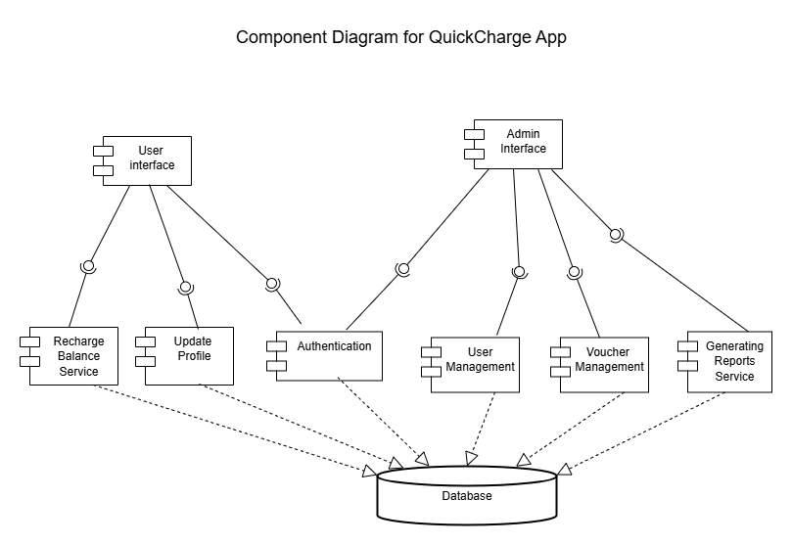

Class Diagram

This Class Diagram is a structural, static perspective of the essence of entities in the Prepaid Recharge & Top-Up Application (QuickCharge). It models the classes in the system, their attributes (their data properties) and operations (behaviors or methods) and the relationship among them. This diagram forms the basis of the data model of the system and how various components of the application are connected at the concept level.
- Purpose: The main item that this Class Diagram is to achieve is:
- Define the major data structures and the information that the application handles.
- Demonstrate the roles of each of the classes in terms of data they possess and things they may do.
- Demonstrate the relationship of various subjects within the system.
- Act as a guide in terms of database design and object implementation of OOP.

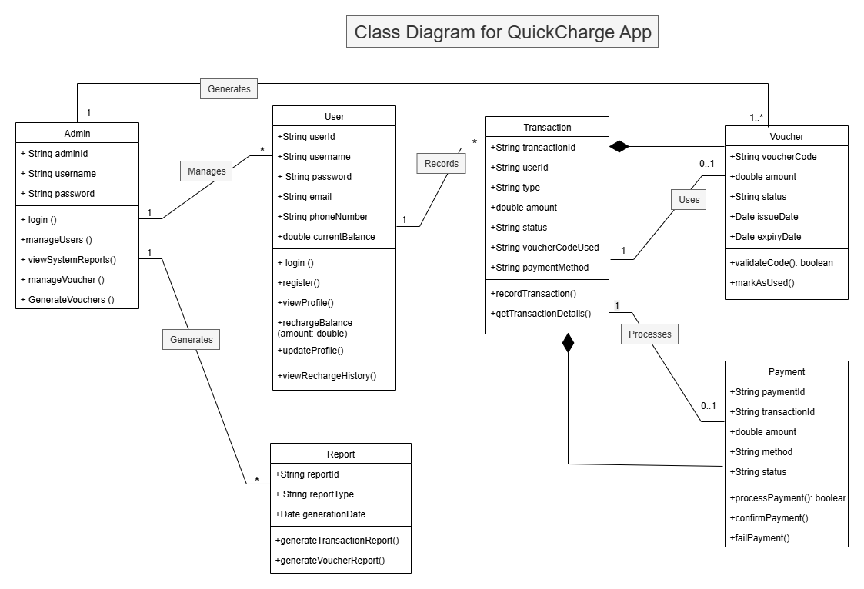

Use case Diagrams (Per functionality)
This Use Case Diagram gives a general view of the functional requirements of the (QuickCharge) application, how the secondary actors will interact with the main actors and core functionalities of the aforementioned system. The diagram is organized in idea 3 major blocks: (End User) functionalities, colored blue, (database System) core processing, colored red, and (Admin) management tasks, colored green.

It specifies the ways in which the End User can log in, manage the profile, recharge using either the voucher or the online payment, get confirmation, and view the history. The System section describes the behind the scenes of verifying voucher, making payments, adjusting balances, giving confirmation and logging the transactions.

Admin section details encompass capabilities of monitoring the system, managing the vouchers, managing the users, generating reports for users transactions and vouchers. Dashed lines show the critical information flow in-between these functional areas, which proves to offer the complete scope of the application and external interactions.

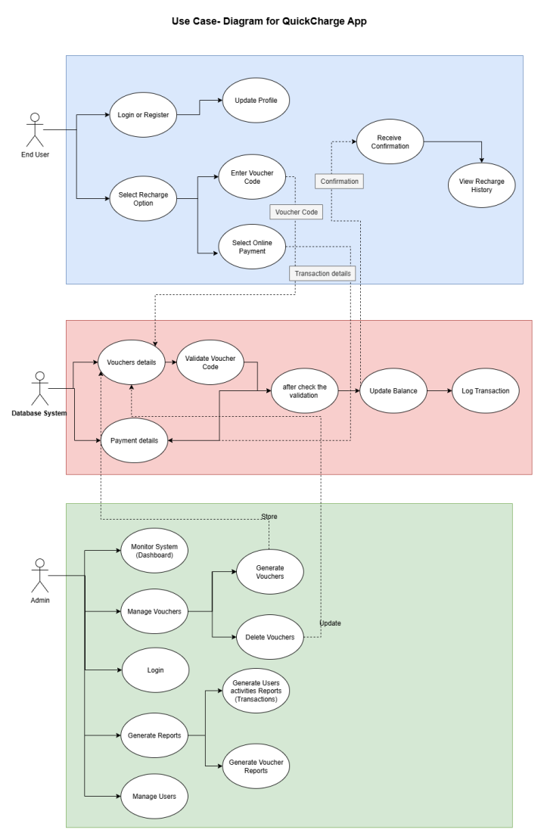

Activity Diagram
This Activity Diagram demonstrates the entire process during which a customer can recharge his/her prepaid balance in the (QuickCharge) application. It displays graphically how the process of requesting a voucher, conducting a decision analysis at various stages of processing, and reaction of the system in response to a voucher-based and online payment described recharge system will flow along with the flow in case of error reporting.
- Purpose: The main aim of this Activity Diagram will be to:
- Demonstrate the detailed sequence of an on-screen flow of the use case Recharge Prepaid Balance.
- Explain the logic and control flow of the voucher based and online payment.
- Find out where decisions are possible and what paths the decisions create (an example is between valid/invalid voucher and succeeded/failed payment).
- Lay a proper ground of the behavior of the system to the stakeholders, developers and testers.

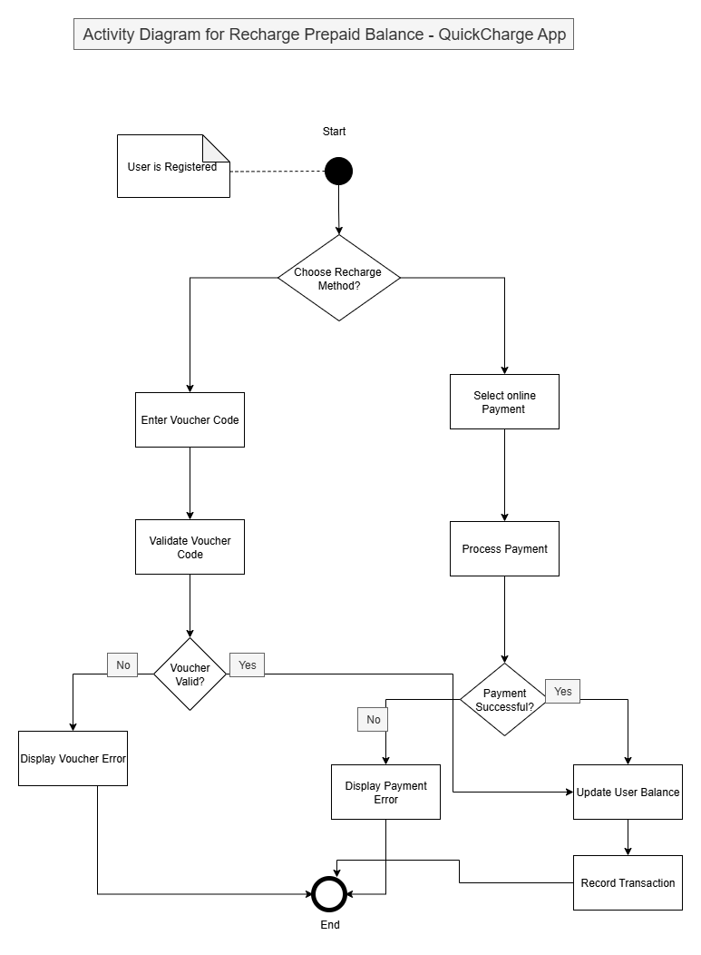

Overall Design

Design Overview
The Overview Design page will give an overview description of the way the QuickCharge system will be composed, arranged and envisioned to work. This part is the point where functional needs meet with the technical specifics. It describes the architectural structure of the system, how the major components in the system interact and how the various actors interact with the application.
This section aims at providing stakeholders (apart of developers, tester and project managers) with a clear perception on how the system fulfills the objectives with the help of intertwined presentations. It determines the major modules of this system, its assignment and the interfaces communicating with each other. Moreover, it discusses some of the design and development features like scalability, modularity and security which will make the architecture able to meet the present needs as well as future expansion which may involve.
In QuickCharge, the focus of architecture design has been modular and layered design. The Presentation Layer manages with the user interaction with the Registered Users and the System Administrators designed two different interfaces. The Application Logic Layer is involved in controlling the business rules, the voucher validation, payment process and generation of the reports. Lastly, the Data Layer is concerned with persistent storage since it provides safe and consistent access to user data, voucher codes and transactions history.
In software design, the design is an important part in which the over-quality, usability and maintainability of the end product is determined. Successful design processes guarantee that a system not only has the functionality that it sets out to fulfill, but also has a feeling of ease and pleasure to those who are using it. The design strategy that will be applicable in the QuickCharge application is one where the visual aspects of design (visual design principles) and the technical aspects of design (technical modeling standards) are integrated to come up with a balance in terms of user experience, system structure and maintainable architecture.

1. Importance of UX / UI Design
The design of the User Experience (UX) and User Interface (UI) are critical to the success of the application, to make it accessible, intuitive, and efficient to navigate and use. The emphasis in UX is the user experience of the entire process, which is to reduce friction when performing actions like voucher inputting, processing purchases, and maintenance of the account. What UI adds to this is the visual focus, typography, colour schemes, where buttons will go, responsive layouts, etc, together with determining that this will look good but consistent on any device. Through the presence of an organized UX/UI in QuickCharge the level of user satisfaction, elimination of error, and overall levels of adoption can be demonstrated.

2. UML (Unified Modeling Language)
UML is a generally accepted modeling language that allowed creating the visual depiction of structure and behavior of a system. Using the UML diagrams, in this case, Use Case Diagrams, Class Diagrams, Activity Diagrams, and Component Diagrams, the design of QuickCharge become clear to developers, testers, and stakeholders. UML assists in the decomposition of more complicated functionality into the smaller fragments in the visual representations, and minimizes miscommunication and enhances development efficiency.

3. ERD ( Entity Relationship Diagram )
The ERD gives the blue print of the data model of the system by visualizing the entities (including Users, Vouchers and Transaction) and relationships. In the case of QuickCharge, the ERD is ideal in certifying an efficient structure of the database as well as a clear association involving user accounts, voucher codes, and recharge history. This does not only facilitate proper retrieval of data, but does also impose data integrity and consistency.

4. Other Modeling Standards, De-Facto Practices
In addition UX/UI, UML and ERD, best practices and de-facto standards in the industry are also factored into the design process of QuickCharge. These include:
- Early-Stage visual design Wireframes, Mockups to conceptualize out early in the process to give stakeholders time to review and approve layout before development.
- Modular, Reusable Code Architecture through Component Based Architecture to improve maintainability, and scalability.
- Coding and Documentation Guidelines to achieve consistency and readablility throughout the development staff.
- Security Design Principles to encrypt information on data and use role-based access control to secure sensitive information about the user.
The integration of these design approaches and principles allows the development process according to QuickCharge to be more comprehensible, consistent, and more effective among the team members and the quality of the resulting software. Such a process makes development smoother with the added advantage of having the application user-friendly, technically stable, and flexible to future changes.

Design Techniques Comparison

The various design methods each play a particular role in the design process of software and care should be taken to ensure proper choice in the selection so as to achieve both a high level of technical efficiency and perceived satisfaction on the part of the user. The comparison of the major design methods that have been used on QuickCharge project is presented below.

1. UX/UI Design
- Purpose: It concentrates on how the user will deal with the system and makes sure that the interface is easy to navigate, visible, and easy to understand.
- Strength: Helps to increase the usability, optimize user satisfaction, shortens the learning process.
- Limitations: It does not directly pursue the context of the architecture of the system or its flow of data, must be supplemented with technical approaches of design.

2. Unified Modeling Language UML
- Purpose: Delivers standard diagrams (e.g., use case, class, component, activity diagrams) to give the view of the system construction and behavior.
- Strength: Enhances communication among the staff members, makes the complicated systems simple, and acts like guidelines of development.
- Limitations: May take a long time to write; expertise in UML notation should be known.

3. ERD (Entity Relationship Diagram)
- Purpose: It is a modeling of the database and presents entities, attributes, and relationships.
- Strength: It guarantees data integrity, facilitates optimum database design, and it minimizes redundancy.
- Limitations: Does not correspond to the user interface or the functionality of the system; it covers only data aspect.

4. Wireframes
- Purpose: Describes graphically the skeleton of a user interface with no details about style.
- Strength: Can be given to get early feedback about layout and navigation; cheap and fast to design.
- Limitations: Unappealing in a visual sense and does not show the aesthetics of the end product.

5. Mockups
- Purpose: This aims to give a high-fidelity and static visual depiction of the end interface design.
- Strengths: Assists the stakeholders to see the final product, in terms of color, typography and branding.
- Limitations: Lacks dynamic behavior, interaction; it is more time consuming and design intensive.

Comparison Summary:
Whereas its UX/UI design guarantees that the application is user-centric, UML and ERD are concerned with technical foundation of the system. Visual tools, such as the wireframes and mockups are fundamental concepts of planning and providing communications on design ideas but should be backed up with the technical diagrams to allow accurate implementation. In the case of QuickCharge, the techniques complement each other so that the overall strategy is balanced, with the user experience and technical robustness being in tune.

Design Tools

The design tools are necessary when elaborating textual ideas into visible and technical views at the stage of software design. They assist designers and developers in drawing wireframes, mockups, diagrams and database models making them clear and efficient to the development. In the case of QuickCharge, picking the right tools can contribute to the speeding up of the develop process, prevention of design mistakes, as well as enhance communication.

- Pros and Cons of each Design Tool

Tool name | Usage | Advantages | Disadvantages
Figma | Cloud-based UI design and mockup/prototype designing tool. | Online collaborative development, on a variety of platforms, no installation, wide collection of UI elements. | Needs internet connection, not much offline features, free plan is partially limited.
Lucidchart | UML, flowcharts and system architecture design diagramming tool over the web | It can be easily operated, be used in real-time and can be integrated with Google Drive or other applications | Few advanced functionality on a free plan, performance can be compromised using complex diagrams.
Draw.io | Web-based diagram graphical editor with support of ERDs, UML diagrams, network maps. | No account needed, absolutely free, available offline, can export in various ways. | Less modern interface than paid tools, less built-in templates than paid ones.
Balsamiq | Web/mobile app low-fidelity wireframe-building tool. | Quick sketching of wireframes, easy drag-and-drop system, promotes attention on structure rather than on the appearance. | Unsuitable on high fidelity designs and does not have interactive prototyping.

The preferable (Anon., n.d.) (Anon., n.d.)
Identify and justify the design tools and techniques you have been selected for the designing of this application.
In order to design the QuickCharge web application, Figma and Draw.io (diagrams.net) will be used as the most effective tools to design and create UI/UX interfaces and technical diagrams, respectively, including UML and ERD. I chose Figma due to cloud-based access and real-time collaboration capabilities as well as a comprehensive assemblage of ready-made design elements that enabled the favorite of high fidelity, interactive prototypes that faithfully predict the ultimate user interface. That would make the design attractive, easy to navigate and responsive to use on various devices.
The reason to select Draw.io rather than other diagramming alternatives is that it is free, user-friendly, and has been able to accommodate numerous diagramming types such as Use Case Diagrams, Activity Diagrams, Component Diagrams, and ERDs. It provides an ease of configuration of diagram layouts and exporting of various formats hence it can easily be incorporated into documentation.
Regarding the methods, UX/UI design principles specified the Figma interface design and guaranteed fluid-like navigation and a positive user experience, whereas UML offered a method of formulating system architecture, actors and procedures on a general basis. The database structure was designed using ERD, which outlined the relationship that existed between the most important entities Users, Vouchers and Transactions.
The QuickCharge project maintains a balance between the user-focused design approach and a well-developed system structure by using Figma on the visual layer and Draw.io on the technical one, which brings transparency to the developers and stakeholders.

High-Level Design (HLD)

Sitemap
The following sitemap is a hierarchical view of the main pages and sections of the (QuickCharge) application. The first page will be the entry page that the users log in and proceeds to the main functions that signed users can access and even provides the areas specific to administrative users.
This sitemap is comprehensive and at a high level, giving a picture of the navigation and how the content is organized into the (QuickCharge) application. It is a graphic plan, which specifies all important pages and sections, presenting their hierarchy relationships. The sitemap will provide a concise representation of the scope of the whole application both of the functionalities visible to customers as well as of the management aspects of administration.
- Purpose: The main point of this sitemap is to:
- Set the full list of navigable pages and functions of the QuickCharge app.
- Show the structure and hierarchy of logical information flow, and lead users through the application.
- Be used as a basis document that guides user experience (UX) design and planning of content, as well as, its development.
- Make all stakeholders share a common picture of the structure of the application.
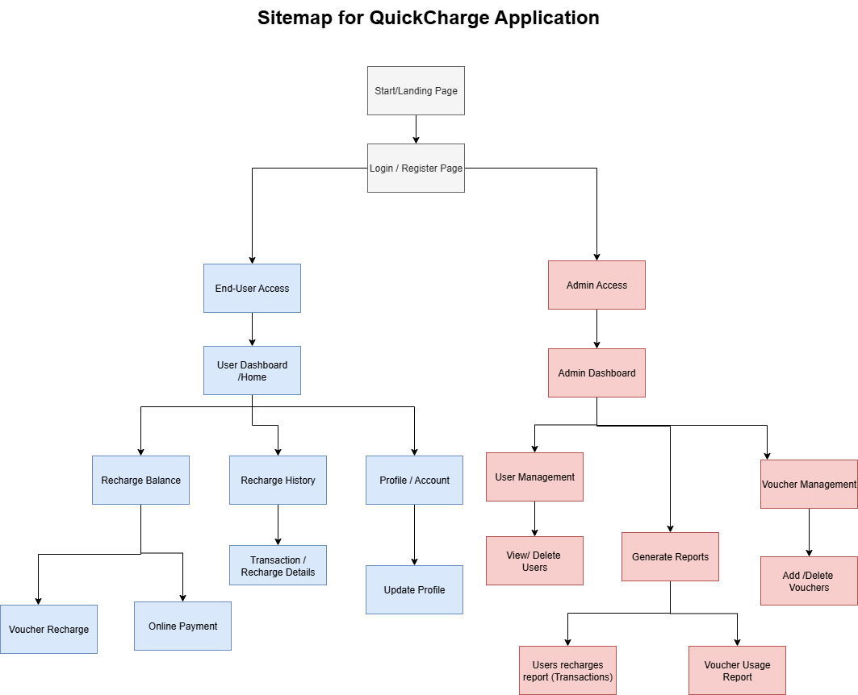

Wireframes
The quickCharge app wireframe design has multiple pages based on low-fidelity wireframe standards with black and white color scheme and Lorem Ipsum dummy text.

The landing page has a straight and centered look with a large title welcoming the user, a series of descriptive text, and two main action buttons to authenticate the user and log in as an administrator, being intentionally minimalistic as is the case with the wireframe prototype. The registration page also provides an organized form structure having line control and labeled tracks of entering the username, email, and password with respective holders, and navigation ties, all written within gray cloning in their color palette to ensure the concentration on programmed structure over visual character. The sign-in screen is the copy of registration in simplified form with more simplified fields to for email authentication and the password authentication to maintain compatibility of the user authentication.

Each page of the wireframes has made use of Lorem Ipsum dummy text across the entire wire frame as a way of representing areas of content without stressed use of real text but in the effort to focus on structural design and elements of user interface. The inclusion of color in the design will draw attention to the color and not to the information architecture, flow and functional requirements, that is the basis of creating effective low-fidelity wireframes, and this is achieved through the monochromatic approach to design of wireframes.

- User Interface

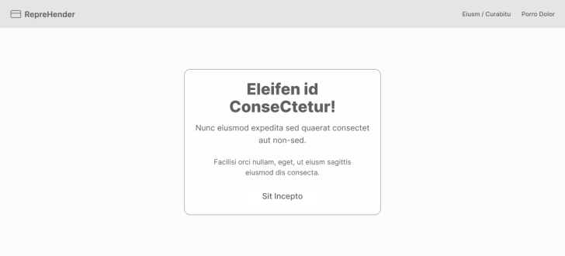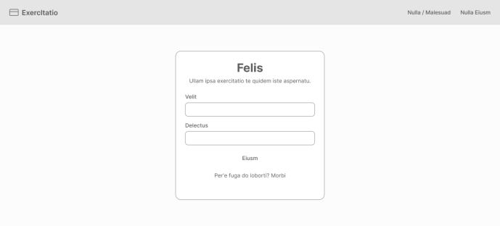
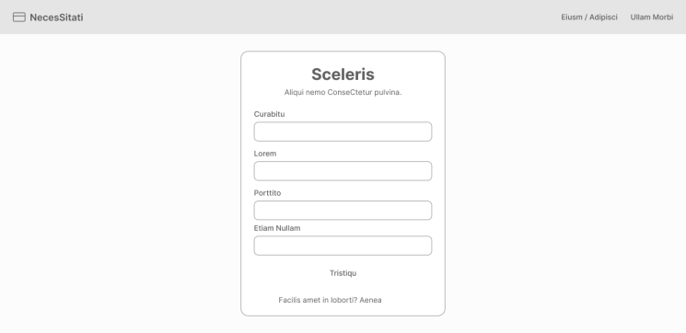
Dashboard Page:
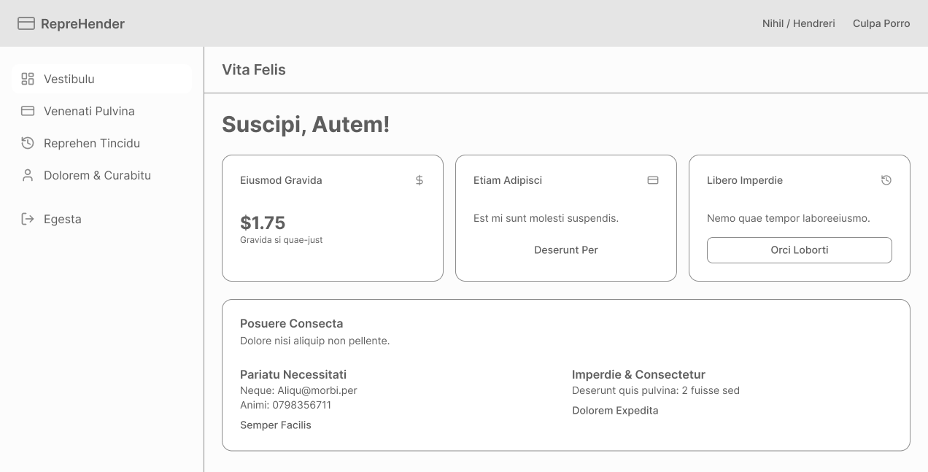
Recharge Page:
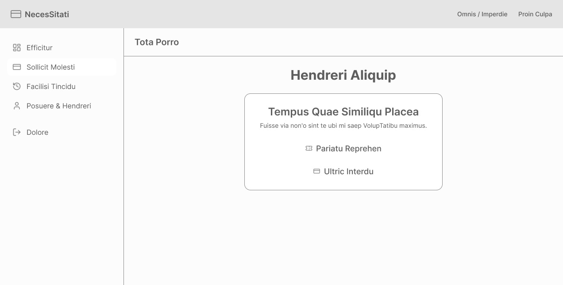
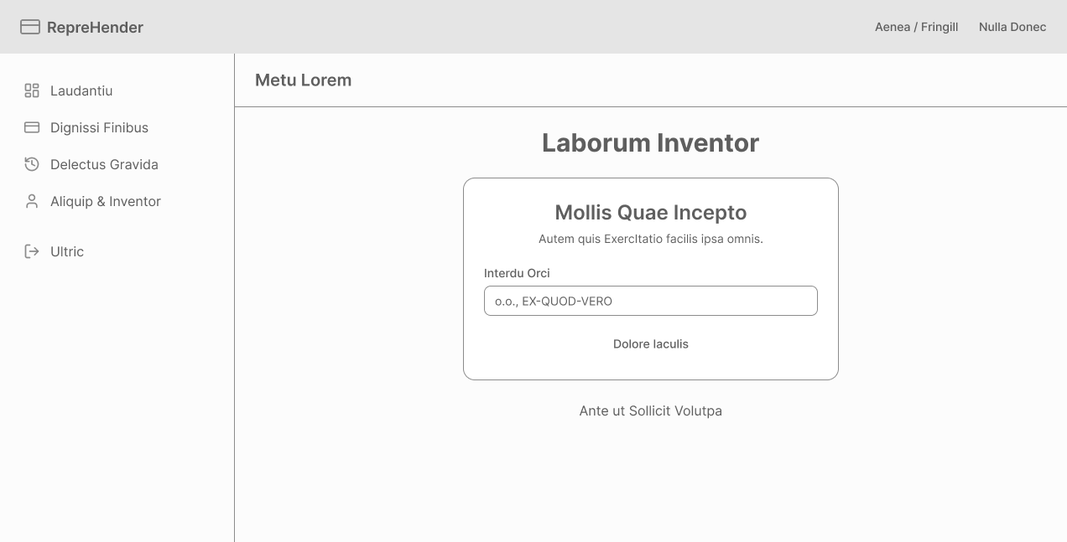
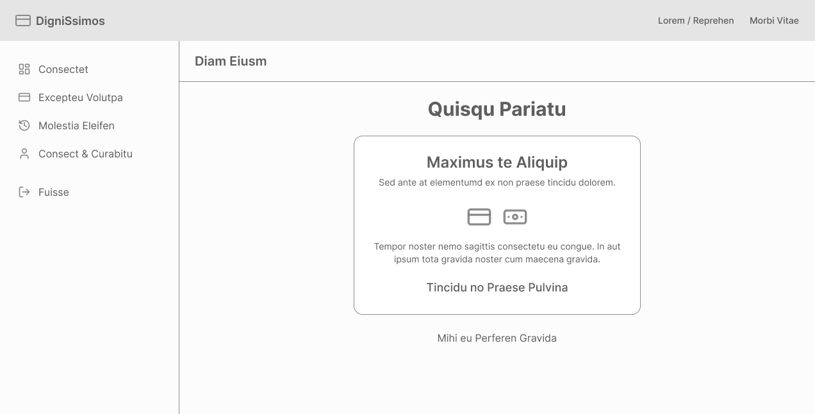
History Page:
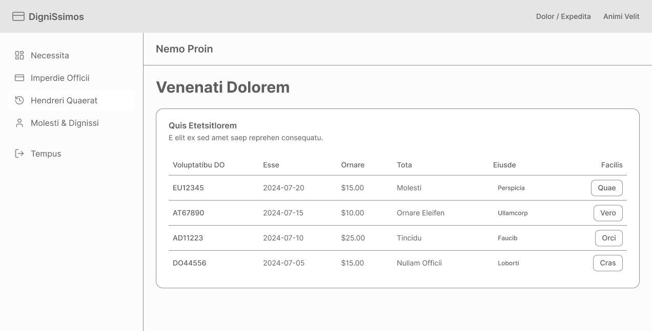
Profile Page:
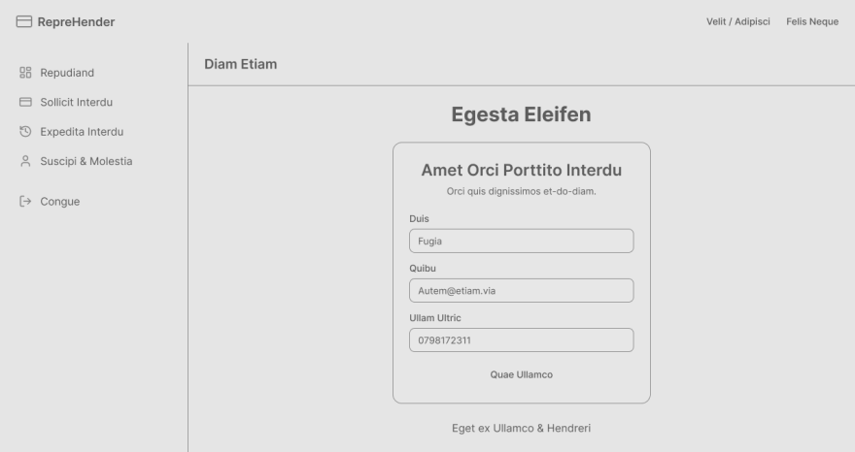

- Admin Interface
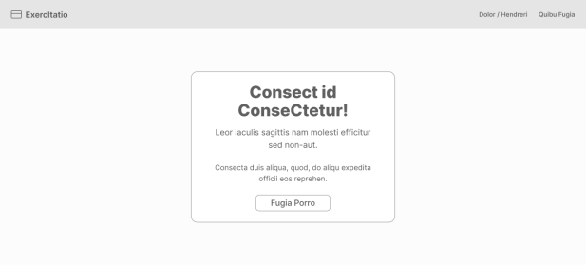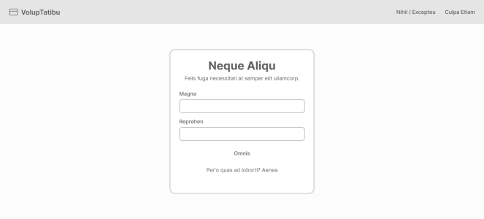
Admin Dashboard
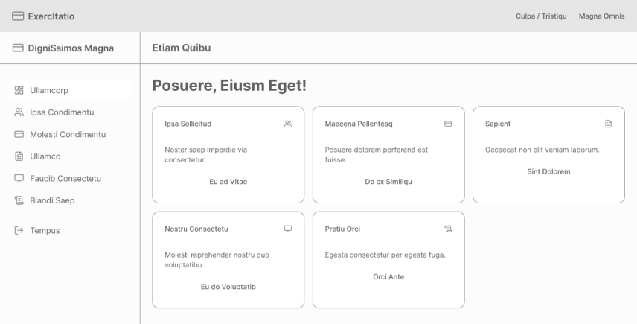
User Management
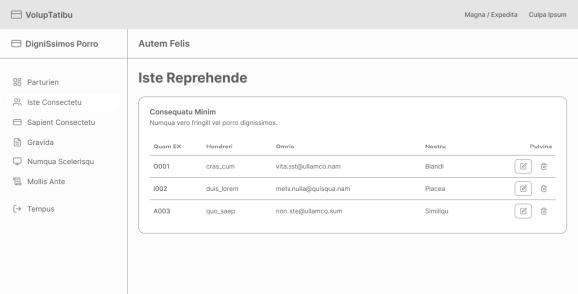
Manage Vouchers Page
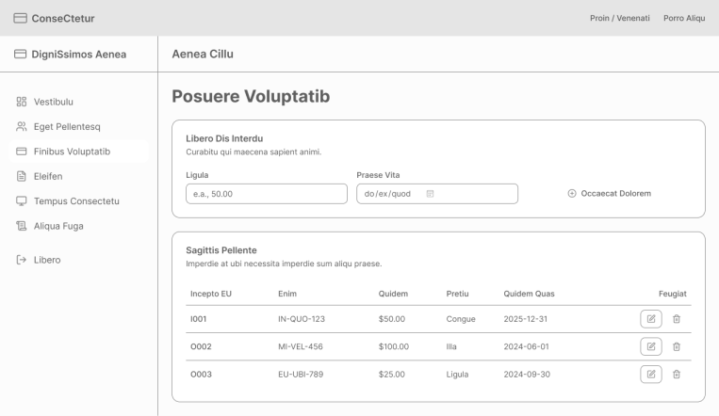
Reports Pages
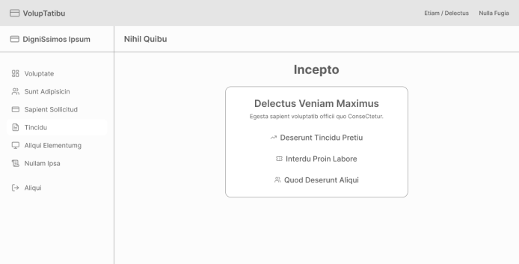
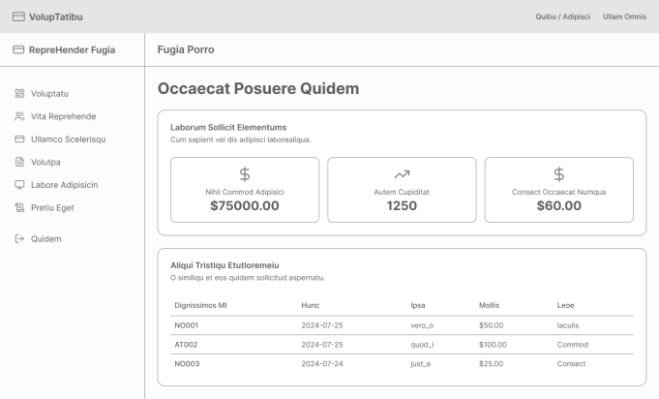
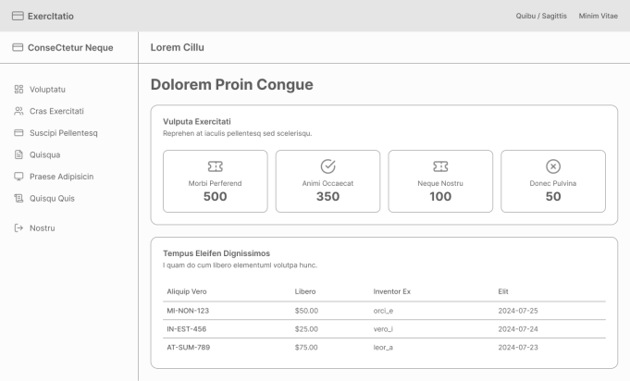

Mockups

The QuickCharge application wireframes offer detailed user interfaces of the user and the admin panels with complete visual design applied. The user mockup has a full dashboard layout which displays sidebar navigation, balance balance display cards, quick action buttons to the recharge activities, and also a table of the transaction history were given with a modern color scheme and professional typography. The user interface features specific pages to redeem prepaid liabilities and process payments online, maintain profile and view detail transaction, which forms an easy to understand interface to prepaid recharge activities.

The admin mockup demonstrates a powerful administrative dashboard with clear navigation, user administration tables, voucher creation forms, powerful reporting dashboards and system monitoring forms. The two mockups were based on real content, the use of correct elements of branding, same visual hierarchy with proper color coding, icons and other interaction features, an indicator of the final visual design that would be deployed in the actual application.

The mockups display the full functionality of the user experience flow (signed-in to finished paid transaction), whereas the management panel shows all the listed management functionalities such as user control, voucher management, and statistical analysis, respectively, giving stakeholders a pictorial view of how the end product would look and operate.

- USER Interface
Welcome Page
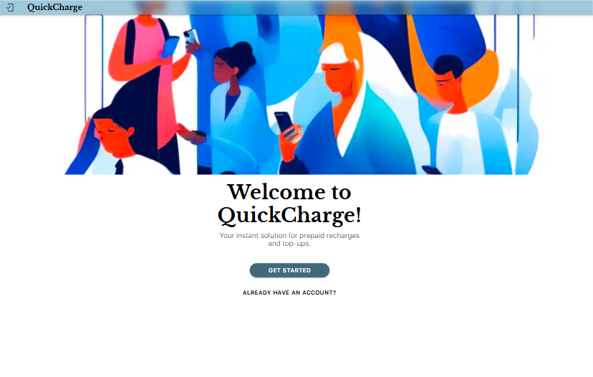
Sign in/up pages
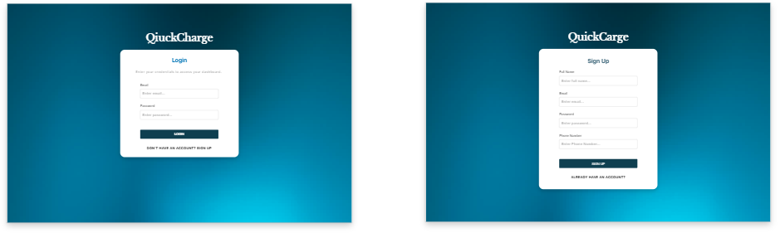
User Dashboard:
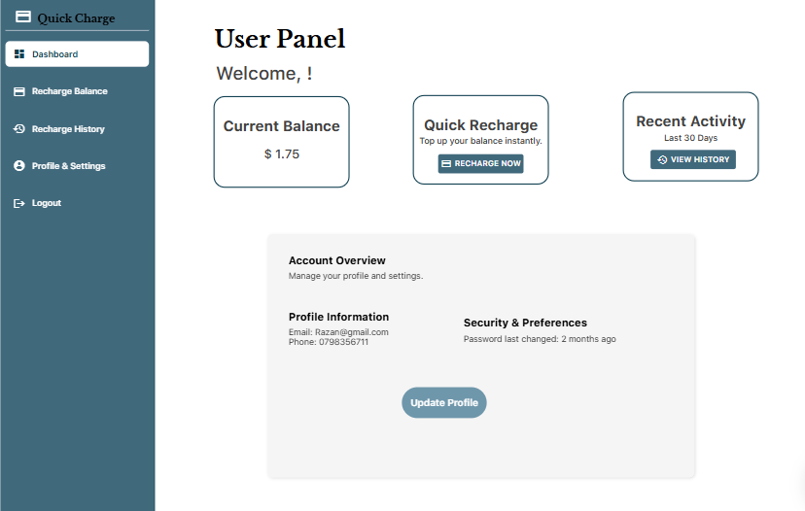
Recharge Balance Page:
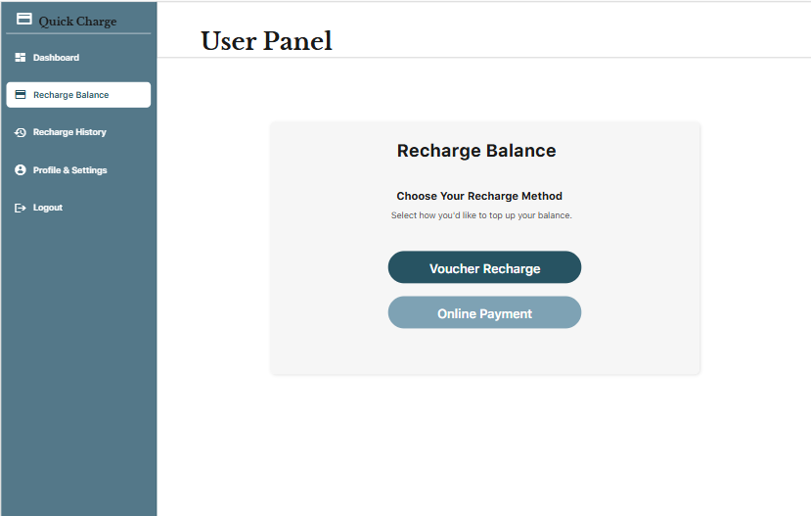
Voucher Recharge Page:
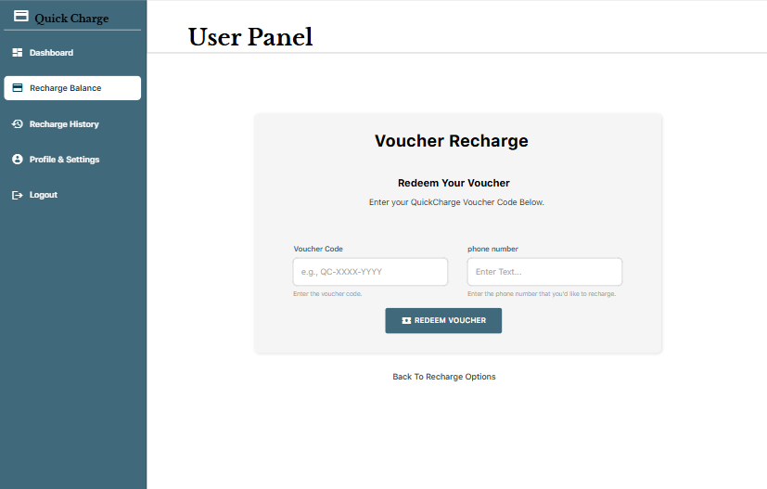
Not-Valid Voucher Page:
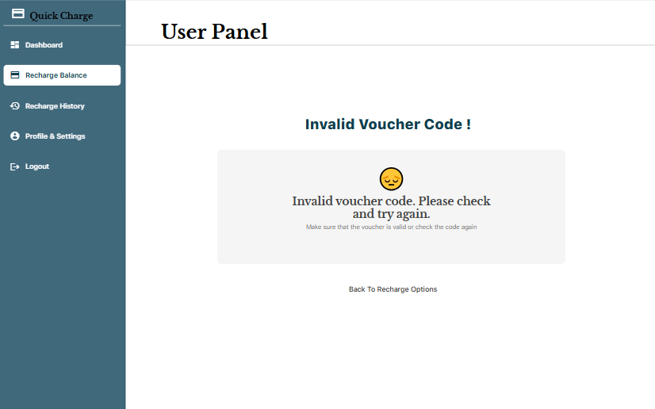
Online Payment Page:
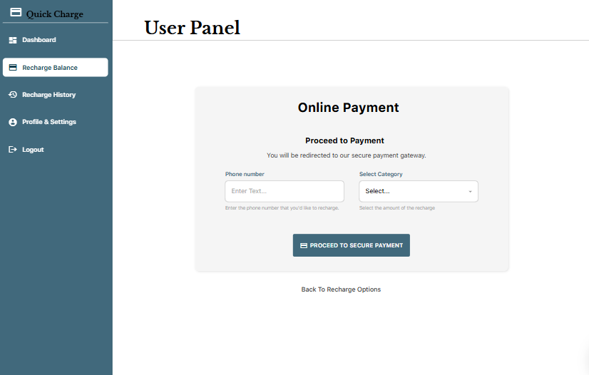
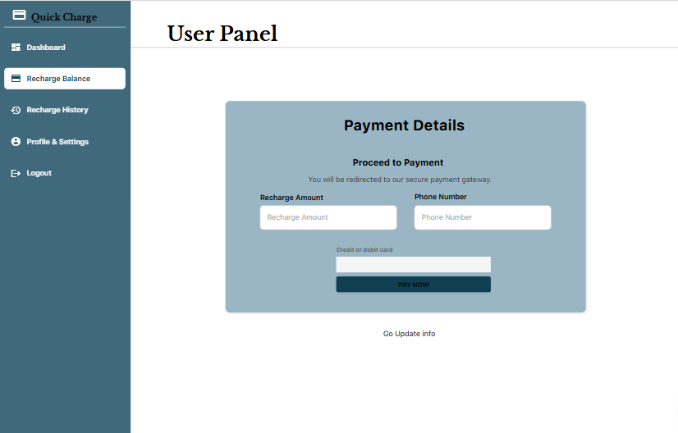
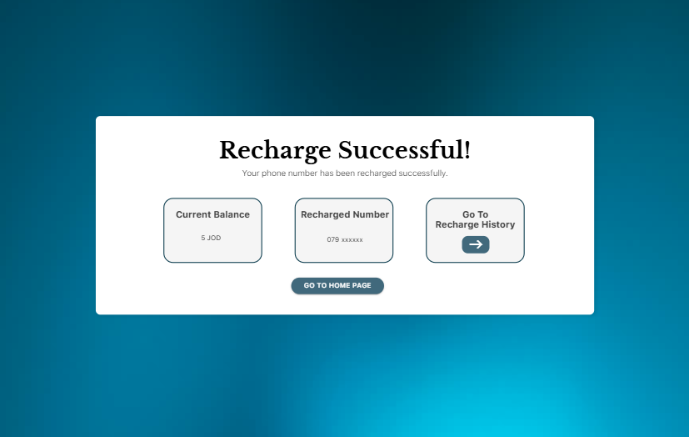

Recharge History Page:
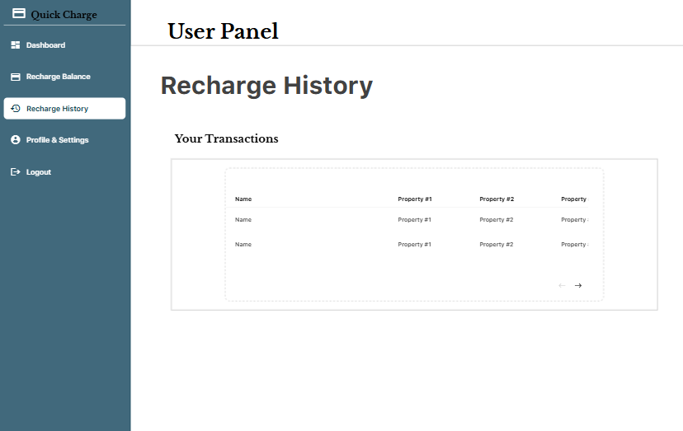
Profile Page:
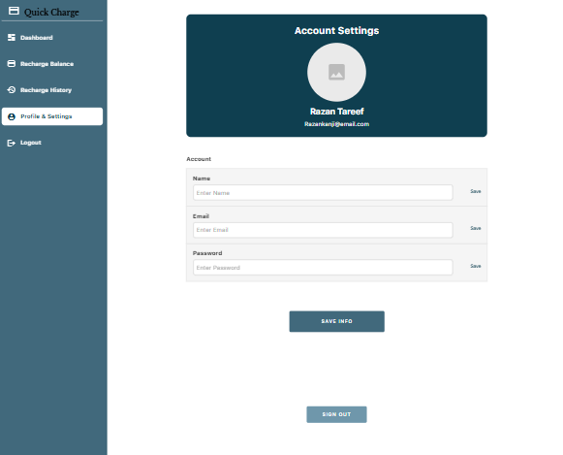

- Admin Interface:
Admin Dashboard:
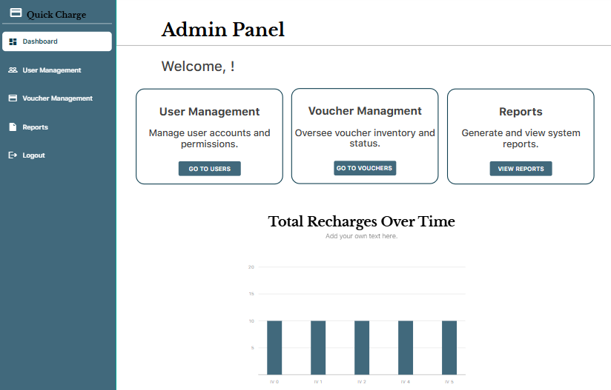
User Management Page:
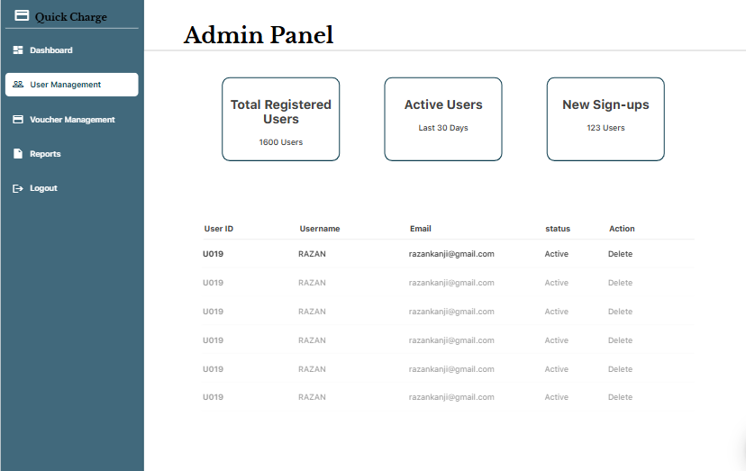

Voucher Management Page:
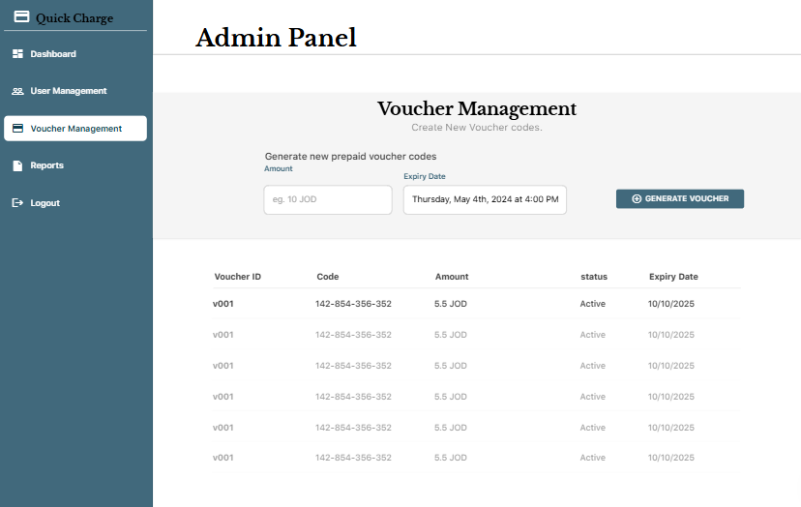
Reports Pages:
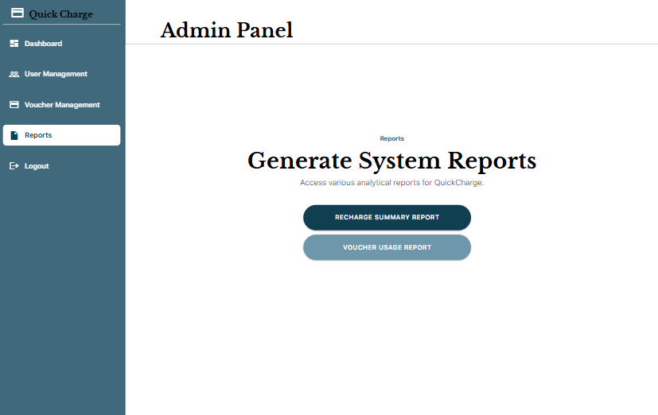
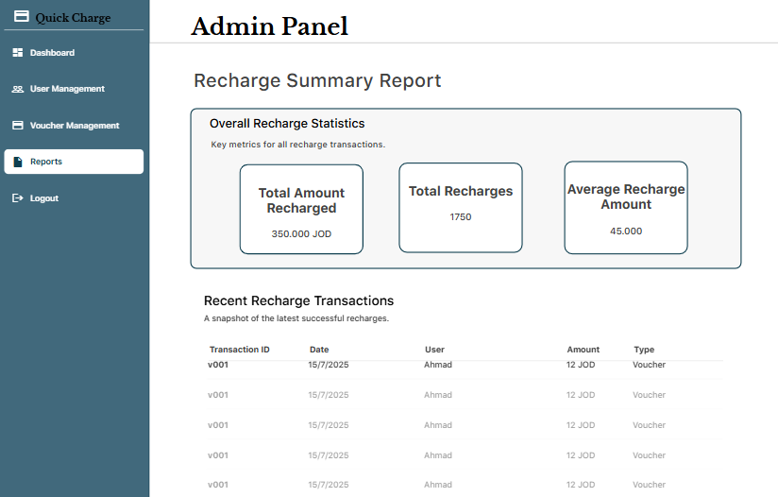
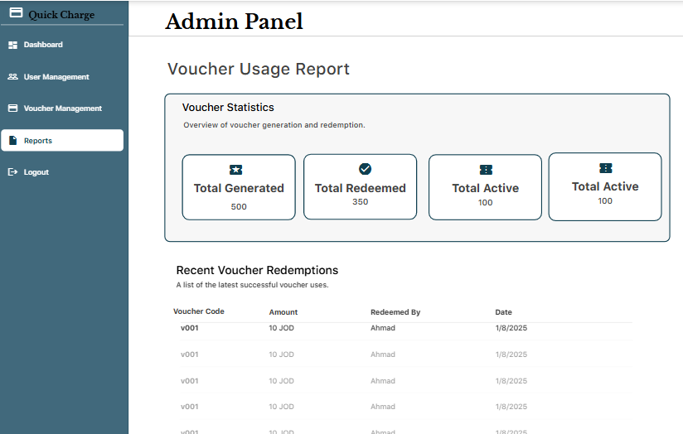

Low Level Design (LLD)

ERD
QuickCharge ERD has six major entities including, User, Transaction, Admin, Voucher, Amount Cateogies, and Online-Payment. The User table contains data about the customer such as balance and the transaction table acts as a hub of all recharge activities we have references to users and payment methods. Admin entity controls the system activities and generating vouchers, the one-to-many relationships with the entity of Voucher is designed. Two ways of processing transactions are available: Vouchers can be redeemed (one-to-one relationship with Voucher) or Online-Payments can be carried out (one-to-one relationship with Online-Payment). The design will provide end-to-end monitoring of all the financial processes, user accounts management and administrative oversight of prepaid recharge system to accommodate both voucher and the digital payment process and data integrity is maintained with appropriate foreign key relationship.

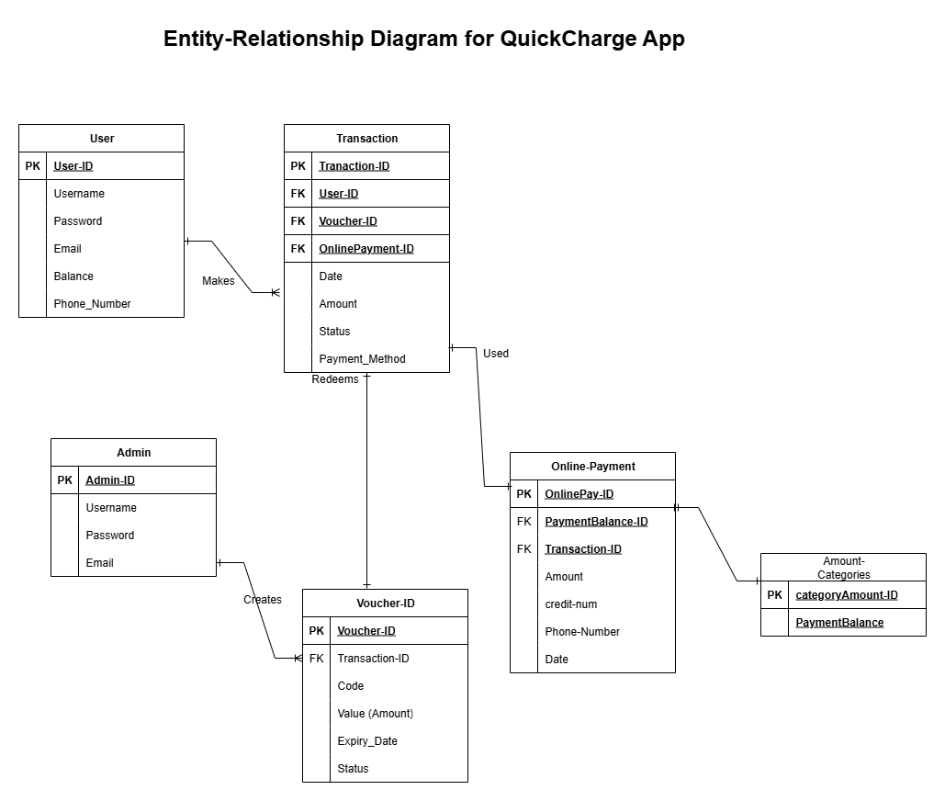

Overall Development

Development Overview

When discussing Rapid Application Development (RAD) platforms, we typically refer to three widely-used approaches: No-Code, Low-Code, and Code Generation platforms. These approaches are meant to accelerate the development process, minimize the amount of manual coding and enable teams to produce software at a faster rate. Let’s dive more into them:
- Rapid Application Development (RAD)
1. No-Code Platforms
- Definition:
No-Code platforms are software enabling applications to be developed in their entirety using only visual interfaces, drag and drop controls, and configuration options, without any custom code. Their primary design is to be used by business users or “citizen developers” who do not necessarily know how to write code.

- How it works:
- Screens are designed by dragging components of UI by developers (or non-technical users).
- Database structures may be defined graphically.
- Logic is developed with the help of simple rules and workflows rather than with the help of programming.

- Examples:

- Adalo (that I used for QuickCharge web app) - enables you to create apps by drag and drop and build databases and workflow definitions.
- Glide - transforms Google sheets into applications.
- Bubble - can be used to construct complete web applications visually.

- Strengths:
- Very quick to develop and deploy applications.
- Reduces the reliance on professional developers.
- Very well suited to MVPs, startups, or basic apps.
- Limitations:
- It can only be customized to the extent that the platform supports.
- There may be scalability and performance limitations.
- Vendor lock-in: it may not be easy to move the app to a new environment.

2. Low-Code Platforms
- Definition:
Low-Code platforms offer visual development tools such as no-code, but can also be extended to use custom scripts or code snippets to add functionality. They are aimed at professional developers who will want to accelerate the development without sacrificing flexibility.

- How it works:
- The majority of the app is developed in terms of visuals (UI, database, workflows).
- When the features of the platform are too weak developers are allowed to inject custom code (JavaScript, Python, SQL, etc.).

- Examples:
- OutSystems - low-code complex application platform.
- Mendix - enables business users and developers to work together.
- Microsoft Power Apps - allows companies to create business applications using bespoke connectors and logic.

- Strengths:
- It is faster than write a code from scratch and more flexible than using the no-code.
- Supports external API integration and business logic.
- Works well with medium and large-scale enterprise apps.

- Limitations:
- Needs technical expertise (not for complete beginners).
- Partially still bound to the platform ecosystem.
- When large use of custom code is needed, the development speed becomes slow.

3. Code Generation Platforms

- Definition:
Code Generation software can automatically generate boilerplate code, templates or even complete modules, based on a high-level specification. In stark contrast to no-code and low-code (where the app is executed within the platform), in code generation, one typically ends up with actual source code that can be exported and now exists as a regular program.

- How it works:
- The platform generates code in a programming language of choice.
- The generated code is extended or customized by developers.

- Examples:
- Yeoman Generators - web applications scaffolders (React, Angular, etc.).
- JHipster - creates full Java + Angular/ React apps based on blueprints.
- Swagger/OpenAPI Generator - generates API client/server software based on API definitions.

- Strengths:
- Allows total control of the code once it is generated.
- Minimizes redundant coding operations (CRUD operations, configurations).
- No vendor lock-in (you get the generated code like you own it).

- Limitations:
- Steeper learning curve than no-code/low-code.
- The code that is generated may be large or non-optimized.
- Even after that developers still have code to maintain and refactor.

- Summary Of Differences:

Approach | Who it’s for | How it works | Examples | Flexibility
No-Code | Non-technical users / startups | Pure drag-and-drop, visual workflows | Adalo, Glide, Bubble | Low
Low-Code | Developers + business teams | It is like the no-code but with custom coding when needed | OutSystems, Mendix, PowerApps | Medium
Code Generation | Developers | Generate source code | JHipster, Yeoman, Swagger | High

Development Techniques Comparison

Software development methods vary widely in the industry with regard to the project requirements, project resources, and long-term objectives. The three primary approaches RAD platforms, full custom development and customization of an existing product all have distinct advantages and challenges.
- RAD Platforms (No-Code, Low-Code, Code Generation)
RAD platforms are fast to develop with visual design tools, pre-existing components, and automation. They reduce the need to manually code, but are extensible via extensions.

- Advantages:
- Extremely quick development and deployment.
- User friendly even to non technical users.
- Less expensive initial development.

- Disadvantages:
- Poor scalability and characteristics.
- Dependency on platform (vendor lock-in).
- Complicated features that are customized can be difficult to create.

- Use Case: Best in startups, MVPs, and small-to-mid size projects where speed-to-market is a concern.

- Complete Custom Development (From Scratch)

- Overview: The system is completely coded in programming languages, frameworks and custom architecture by developers. This has the greatest control and flexibility.

- Advantages:
- Complete personalization and management of all the system.
- Scalable and adjustable to enterprise level requirements.
- Easier integration with third party.

- Disadvantages:
- More time and expensive development.
- Needs competent programmers and more staff.
- Increased complexity in maintenance.

- Use Case: Suits large systems, mission critical applications or long life cycle enterprise solutions.

- Customization of an Existing Product:

- Overview: An existing platform or product is used, rather than being implemented as completely new code.

- Advantages:
- Shorter development time than building from scratch.
- Draws on prior, proven solutions.
- It often has in-built best practices.

- Disadvantages:
- Less flexibility (because fixed by base product design).
- May contain extraneous characteristics (feature bloat).
- Expensive licensing or subscription fees.
- Use Case: Appropriate when the necessary functionality is very similar to an existing product (ex. ERP system customization or CRM).

(Anon., n.d.)Development Tools

The development tools that are selected during the lifecycle of the software project largely determine its success. The tools of development are the starting point to creating, testing systems and deploying applications and their choice dictates the trade-off between speed, flexibility, scalability and maintainability. Currently developers and organizations have a vast selection of tools, with no-code/low-code tools speeding up delivery with little to no code, up to fully featured Integrated Development Environments (IDEs) that provide full control over system structure and performance.

Software development is an area where tools greatly influence the pace, quality and maintainability of the project. There are tools that are tailored to specific settings, such as low-code / no-code solutions, up to full-fledged Integrated Development Environments (IDEs). Below, there is a comparison of four most popular development tools in terms of their use, disadvantages and advantages.

This section compares the four popular development desktop applications Adalo, Visual Studio, Android Studio, and Xcode, describing the applications, their pros and cons. That comparison can offer an understanding of how various tools fit into various project needs and allow justifying the selection of tools used in the QuickCharge application.
Table 2 Advantages and Disadvantages of types of each development tool
Tools name | usage | advantage | disadvantage
Adalo (No-Code Platform) | Rapidly developed mobile and web apps with drag-and-drop user interface and built-in database capabilities. | -Quick editing and visual editor.  -No technical skills in coding.  -Combined workflows and database.  -Ideal for MVPs and startups. | - Little ability to customize sophisticated features.  - Vendor lock-in (difficult to move to the next platform).  - Enterprise level app scaling problems.
Visual Studio (Microsoft IDE) | Full-fledged IDE based on .NET, Csharp and other Microsoft technologies. Backs up backend APIs, desktop, and web applications. | - Powerful debugging tools.  - Enterprise-grade development.  - Microsoft Azure cloud integration.  - Scalable backends: great to build. | - Steep learning curve.  - Resource-intensive.  - Less fast than low-code platforms to prototype with.
Android Studio (Google IDE) | Main IDE to develop native Android programs in Java or Kotlin. | - Google-officially supported tool.  - Good choice to create native Android apps.  - Huge developer base and asset bases.  - High level of customization. | - It is Android-based only (not cross-platform).  - Slower development time.  - Must have good coding ability.
Xcode (Apple IDE) | Swift or Objective-C native iOS and macOS framework used to create applications. | - Apple ecosystem optimized.  - iOS development high performance.  - Built in with Apple developer tools and testing. | - Only for Apple devices.  - Requires macOS.  - not endurable to cross-platform development.

- Analysis:
- Adalo would be the most rapid development and the minimum code needed.
- Visual studio is superior at doing backend and enterprise-grade.
- Android Studio can be used with native Android apps and is entailed with good coding skills.
- Xcode is required to support native iOS applications but criminalizes cross platform opportunities.

The preferable Development Tool and Technique
To develop the QuickCharge prepaid recharge and top-up application, the chosen mode of development is Rapid Application Development (RAD) methodology, which is being executed on the Adalo no-code platform. This was decided upon in order to achieve a balance between speed, simplicity and functionality so that a working system can be delivered within the allocated project time and academic scope.

- Justification for the Development Tool (Adalo):

- Rapid Prototyping: Adalo enables the team to create mobile and web interfaces quickly with a drag-and-drop editor, allowing them to create working prototypes and collect feedback as early as possible.

- Built-in Database Integration: The platform includes its in-built database, which makes it simpler to transact with users, vouchers, transactions and balances without using an external backend at the early stage of development.

- Workflow Automation: Adalo enables visual workflows, including logic, validations, and data: this feature minimizes the use of complex code. This is especially adaptable to functions like redeeming a voucher, and real-time updating of user balances.

- Cross-Platform Deployment: App deployment to both iOS and Android can be done with just minor modifications, thus making the application more accessible to a larger user group.

- Simpler Development Process: The no-code model enables the team to avoid the complexity of configuring individual backend services, APIs, and code-based frameworks that would otherwise add cost and time overhead.

- Justification For the Development Technique (RAD/No-Code):

- Time Efficiency: RAD fits into the short academic schedule of the project where a full operational system can be developed and demonstrated in weeks not months.

- Focus on User Experience: As you do not need to spend as much time on coding to build infrastructure, more of your time can be devoted to creating intuitive Ui/ux screens as these are the key to customer satisfaction.

- Flexibility of Iteration: RAD promotes iterative development, meaning that features can be refined and enhanced by continually getting feedback about them and their use by test users and stakeholders.

Using Adalo as the key development tool and relying on the RAD/no-code approach, QuickCharge can enjoy the benefits of a shorter development time, reduced complexity, and user-friendly design approach. Although a full custom coding can be more scalable as time goes by, the approach taken is most suitable in the current scope since project requirements can be achieved efficiently and effectively.

Software Development Methodology

To prepare the QuickCharge Prepaid Recharge and Top-Up application, Rapid Application Development (RAD) methodology is selected. RAD focuses on prototyping, feedback, and user engagement, thus it is best appropriate in projects where time is the most vital element, and usability is equally important. RAD is a perfect match since QuickCharge is being developed in an academic time frame and needs to get a functional system deployed promptly.

- Advantages of RAD Methodology:

- More Rapid Development Cycle: RAD facilitates rapid prototyping and fast iterations, with an effective app able to be created much more quickly than traditional development approaches.

- User-Centered Approach: The user is often involved in the design and testing of the system, thus ensuring that the system addresses the actual user needs and expectations.

- Flexible to change: Requirement or design changes can be adapted easily without significant impact.

- Less Development Risk: With prototypes and early testing, significant problems can be discovered and resolved before they are actually deployed.

- Focus on UI/UX: UI/UX is more important to RAD, and it is essential to QuickCharge because the customer experience should be easy and friendly.

- Disadvantages of RAD methodology:

- Scalability: Scalability is limited in that the RAD can only support small and medium-sized applications; achieving the target scalability at an enterprise level may be difficult without rewriting the code.

- Tool Reliance: The approach is rather over-reliant on low-code/no-code tools (e.g., Adalo) which might cause platform lock or vendor lock-in.

- Increased Purchase Price on Complex Features: When your application includes complex custom features, RAD might not be cost effective in comparison to full custom development.

- Needs Feedback by the User: RAD is an iterated work process that requires user input, or it can be biased in the wrong direction.

- Justification for QuickCharge
QuickCharge application will need to be developed fast, easy to use, and flexible to develop iterations, which also coincide with the RAD approach. Adalo is a no-code development platform, which allows the project team to develop prototypes, test them with users, and refine the design faster, without using a lot of code. Scalability and high sophistication of customization is a weakness, but these are tolerable trade-offs considering the academic nature and limited scope of the project.

Hence, the most suitable methodology is RAD, which will guarantee that QuickCharge will be rolled out successfully, in time, and with end user satisfaction.

Overall Design and Development Justification

Any software project cannot just be built to get a working system; it should also be explained on how the design and development decisions address the problem behind the business successfully. The QuickCharge application was designed to overcome the following real-life problem: How do we equip our customers with a quick, reliable and user-friendly method of replenishing their mobile balances? How do we also equip an administrator with tools to manage the vouchers, users and transactions? To do this, alternative design techniques, development methodologies and tools were studied and compared. This section contains the justification of the selected solution by describing why the embraced design practices, Rapid Application Development (RAD) methodology, and the Adalo no-code platform is the best combination to fit the objectives, limitations, and business requirements of the project.

- Business Problem and Proposed Solution “QuickCharge”
The concept of the QuickCharge Prepaid Recharge and Top-Up Application is the solution to a clear business issue: customers need to recharge their mobile balances fast, with certainty, and without necessarily going to physical stores. The application saves telecom providers operational expenses through digitalization of recharge operations, enhances ease of use to customers, and offers insights to understand user behavior based on the transaction data.
In assessing the potential software design and development strategies, three main factors were taken into account: time limitations, business goals, and usability expectations of users.
- Design Justification
In terms of system design, UML diagrams, ERDs, and UI wireframes/mockups were used to ensure the architecture, database, and user flows were properly mapped prior to implementation. Such systematic design will minimize the ambiguity level of any design approach, ease communication among the stakeholders and make the app user-focused. The focus on UX/UI design was necessary, since the success of QuickCharge relies on the ability to offer a simple, user-friendly interface to customers and offer administrators powerful management tools.

- Justification of Development Methodology.
Rapid Application Development (RAD) was the methodological choice compared to other approaches, e.g., Agile or Waterfall. Though Agile is scalable and Waterfall focuses heavily on documentation, RAD was more appropriate because of:
- Shorter delivery times, which match the academic deadlines of projects.
- High user involvement, so the design is what is expected by customers.
- The iterative prototyping process that can be used to test and refine features quickly.
- Though RAD has some limitations on scalability, it can suit the immediate demands of the project and guarantees functional delivery within a limited time period.

- Justification of Development Tools:

A number of development tools were reviewed, such as Adalo, Visual Studio, Android Studio, and Xcode. Traditional IDEs (Visual Studio, Android Studio, Xcode) are powerful to customize and scale, but they need a lot of knowledge, time, and resources in terms of coding. On the contrary, Adalo, a no-code RAD platform was selected as it lets you:
- Quick development and roll out of mobile and web apps.
- Built-in database integration to handle users, vouchers and transactions.
- Cross-platform compatibility that can be deployed on iOS and Android.
- Consider the user experience, which the tool takes designers out of the bad side of backend development to give more time to the UI/UX design.

- Conclusion
Using the RAD methodology, combined with the structured design method (UML, ERD, wireframes), and Adalo as the development tool, QuickCharge will find the appropriate balance between the business requirements and technical feasibility. This would help provide a complete-fledged working recharge system operating under the project schedule, and would also respond to the greater business objective of increasing customer satisfaction and lowering operational expenses.

Development Plan Presentation

Peer review feedback

The instructor gave me proper feedback during the formal presentation of the QuickCharge project, which would strengthen the quality of the Software Design Document (SDD). Among the main suggestions were the risks section, in which it was proposed to add the cost and penalty rating to the prior levels of priority. This would render the risk assessment more professional. The other comment was on the component diagram, in which the instructor advised that modifications needed to be made to the network of the system components to make the relationship and structure between the system components more accurate and logical.

Additional comments were provided on the use case diagram in which the instructor recommended that the diagram should be described in a more precise manner to clarify the process by which actors interact with the system. It would be useful to make sure that the diagram is visually adequate as well as a well-supported diagram with a good text explanation. Moreover, the wireframes were also identified as the area that needed improvement, and it was suggested that there should be consistent and clear design standards throughout the interface mockups. This would enhance general professionalism and usability of the UI/UX design.

Otherwise, the instructor affirmed that all other areas of the presentation and documentation were well prepared and met expectations. The responses will be used to improve the documentation and design to ensure that the final project will be clear and comprehensive.

Interpret the peer review feedback
Modify your Software Design Document to interpret your peer review feedback and reflect any new insights or considerations.
Based on the comments given after the presentation, the QuickCharge Software Design Document was improved in a number of ways. Other factors like the cost and penalty rating were added in the risks section providing a deeper level of analysis and enabling a more accurate ranking of risks. The component diagram was also updated to improve the relations between the components of the system and make them more logical and readable. Equally the use case diagram has also been revised to include a more explicit textual description, which now simplifies the interactions between actors and the system.

Moreover, the wireframes were also tailored to share alike norms with regards to layout, labeling, and alignment which enhanced the clarity as well as the professionalism of the interface design. These changes were not only responding to what the instructor said, but also offered important suggestions on how structured feedback can address the design artifacts. Consequently, the revised SDD has more detailed, precise and user-friendly description of the QuickCharge app.

Identify and evaluate new opportunities

In addition to the feedback received in the context of the peer review, other sources of enhancement of the QuickCharge application were found in further consideration of the design and functionality of the system. Such opportunities were not originally planned but were identified as the possible improvements that could add value to both the customers and the administrators.

The introduction of a notification and reminder system is one of the new opportunities. Although the existing system provides the user with the ability to recharge balances, it does not attempt to engage them post-transaction. The inclusion of notifications like low balance warnings, recharge confirmation, or promotional offers may help more users engage and customers will never run out of credit without warning. This was considered a very good improvement since it has a direct effect on customer satisfaction and customer loyalty. But since this is a time constrained academic project, this feature has been recognized but not added to the first version. It is still a viable option in the future.

The other possible enhancement is multi-language support in the application. Because mobile recharge systems can be used by various types of users, it will be better to offer the interface in various languages to make the app more inclusive and easier to use, especially when the application is used by non-English speakers. The opportunity was considered and found worthwhile in an actual business, but not factored in the current project scope to ensure that the original version is simple and within the available resources.

Another new revelation administratively was the prospect of advanced analytics dashboards. Although the current admin interface provides simple statistics (i.e. the number of users and total recharges), it may be extended to offer trend analysis, the most frequently used payment options, and revenue distributions, which would provide telecom providers with valuable business intelligence. This one was considered a medium-to-high priority to deploy in the real world, but in the academic project, only simplified reporting is involved because of technical and time limitations.

Another area of possible improvement was also identified as security. Although the existing system already uses the basic authentication and the role-based access control, it is possible to apply two-factor authentication (2FA) as an additional security measure. This would go a long way in minimizing the occurrence of unauthorized access to the accounts. The addition of 2FA was however considered out of scope in the present version, since it involves further technical integration outside the immediate objectives of the project.

Along with this, future releases of QuickCharge can include loyalty and rewards systems, such as earning points or discounts when recharging regularly. This would provide a competitive edge to the feature as it would promote repeat usage. It was considered as a potential business opportunity but this was not part of the current scope of the project as the primary aim was to provide the fundamental recharge functionality.
Overall, the reflexive exercise demonstrated that the future could be improved in a variety of ways such as notifications, multi-language support, advanced analytics, improved security features, and loyalty programs. Although these enhancements were not part of the present academic version because of scope and time constraints, they give clear guidelines on how the application can be up-scaled to a more robust, user-friendly and commercially competitive solution in subsequent development cycles.
- New Opportunities for QuickCharge summary:
New Opportunity/  Feature | Benefit / Value | Reason for Inclusion / Exclusion
Notification & Reminder System | Enhances customer interaction with low balance notifications, recharge messages and deals. | Very useful to customer satisfaction, but not included in the scope of this work because of time constraints.
Multi-Language Support | Provides greater access and inclusivity to a variety of users. | Useful in a real-world business situation, but omitted to make first version simple.
Advanced Analytics Dashboard | Gives admins an overview of the trends, payment patterns and revenues. | Critical to scalability in the long term; simplified reports are only presently due to technical constraints.
Two-Factor Authentication (2FA) | Improves security of the account and prevents access by other persons. | Powerful security capability and need to be further integrated; not within the scope of academic project.
Loyalty & Rewards Program | Promotes the repetitive usage and customer loyalty. | Very good business strategy but not part of it as the project is aimed at providing base features.

Application Development

Database

One of the essential parts of the QuickCharge application is a database, as it is the place where the most important data that will run the system is stored, managed, and retrieved. Features like voucher redemption, online payment transactions, balance updates and recharge history would not be stable without a well-organized database. The database maintains the organization, consistency and real-time availability of all information that can be utilized by all customers and administrators to interact with the application.
because i built my application with adalo, Adalo has an in-built NoSQL-type database (collection-based) that is automatically linked with the app. Adalo already has an in-built no-no-code database (built-in database) to store collections such as Users, Transactions, Vouchers, etc.

- QuickCharge database design was created based on the concept of Entity-Relationship Diagrams (ERDs), which visually depict the entities, attributes, and relationships needed in the database. The key entities include:

- User Table: This table contains details of the customer like user name, password, contact and balance.

- Voucher Table: It stores the voucher codes, values and usage status (redeemed or not).

- Amount Categories table: it has all the recharge balance that the user could pick when they choose online payment.

- Transaction Table: This database contains all the recharge activities, which are attached to each user and the type of payment made (voucher or online).

- Online Payment Table: This is used to manage payment records of the transactions that have been executed through the payment gateways.

It is relational, i.e. the tables are connected via primary and foreign key, which guarantees the integrity of the data. As also shown as an example, the transaction table is linked to both the user table and the voucher/online payment tables, such that administrators can produce the correct reports and users can see their history of recharges.

Such relational design would ensure that all the operations including redeeming a voucher, online payment, and even checking a balance are done efficiently and securely. Consequently, not only does the database form the core part of the operation of QuickCharge, but also makes the system scalable, reliable, and in tandem with the industry standards in terms of processing transactional information.

Screenshots of your application
Here is the link of Adalo :
https://razan-khanis-team.adalo.com/quickrecharge?target=82a14ee97f50459a86442571d17f2bcd&params=%7B%7D

- USER Interface
Welcome Page
Sign in/up pages
User Dashboard:
Recharge Balance Page:
Voucher Recharge Page:
Not-Valid Voucher Page:
Online Payment Page:

Recharge History Page:
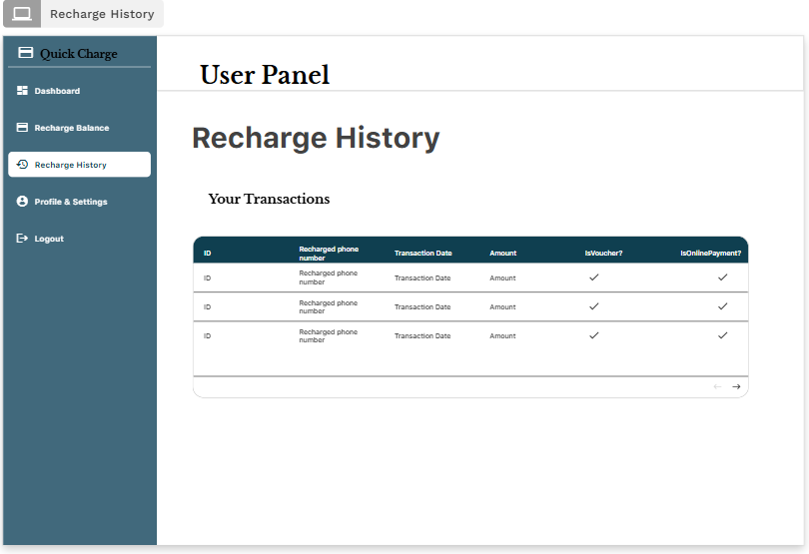
Profile Page:
- Admin Interface:
Admin Dashboard:
User Management Page:
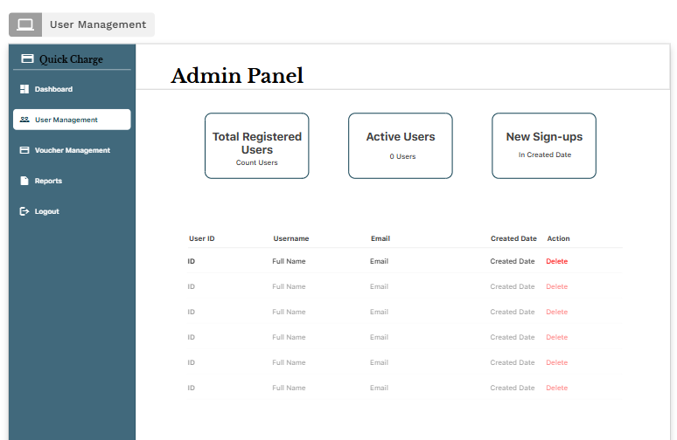

Voucher Management Page:
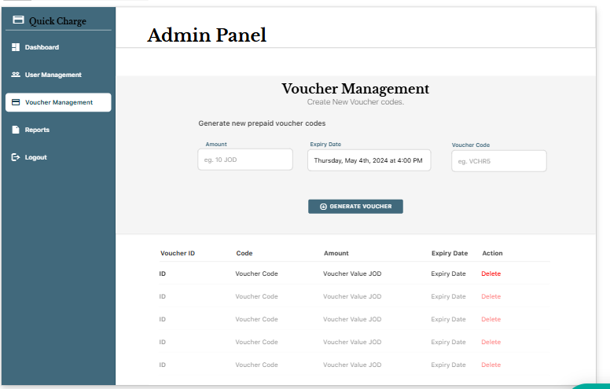
Reports Pages:
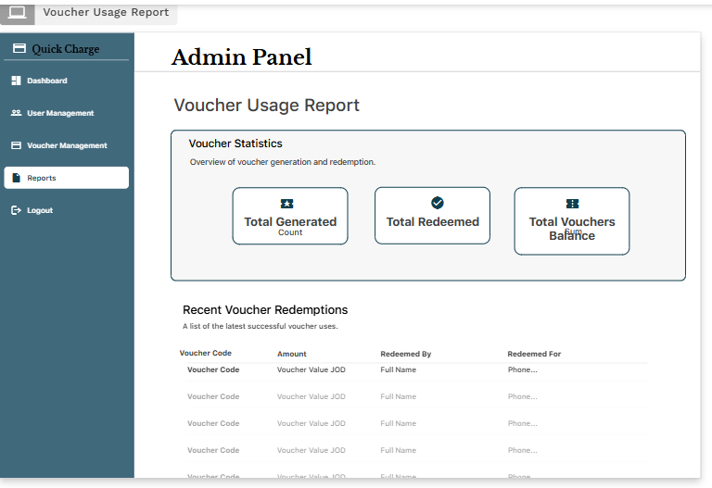

Testing

Testing plan

Software testing is a crucial stage in the development of an application that must guarantee the functionality, stability and fulfill user requirements of the system. In the case of QuickCharge application, testing will be used to confirm the functionality of the main modules (authentication of users, voucher redemption, online payments, balance updates and administration of the application), non-functional modules to be tested include performance, usability, and database reliability. A unique identifier, module, assumptions, priorities, and scenario have been recorded in each test case to cover all the aspects.
- Test Cases:

- Test ID: TC-001- Update User Profile
- Module: User Management
- Test Data:Username: razan, New Email: razan@gmail.com/ phone number: 0793943554
- Assumptions: User has logged in.
- Priority: Medium
- Scenario: Check that users are able to successfully change their profile details and changes are reflected in the database.

- Test ID: TC-002 – Redeem Voucher
- Module: Voucher Management
- Test Data: Voucher Code: VHCR10, Value: 10 JOD.
- Assumptions: 1) user must be logged in and 2) voucher must exist in database.
- Priority: High
- Scenario: Justify voucher redemption and balance update and error management in used/invalid voucher.

- Test ID: TC-003 Online Payment Recharge.
- Module: Online Payments.
- Test Data: Amount: 20 JOD, Payment method: Credit Card.
- Assumptions: User is already logged in, and is connected to payment gateway.
- Priority: High
- Scenario: Authenticate successful payment, failed payment and time out scenarios.

- Test ID: TC-004 - View Recharge History.
- Module: Transaction History
- Test Data: User ID: 1001 having past transactions.
- Assumptions: User must be logged in and must have at least one or more previous transactions.
- Priority: Medium
- Scenario: Make sure that previous recharges have been retrieved and shown appropriately.

- Test ID: TC-005 - Admin Generates Report.
- Module: Admin Dashboard
- Test Data: Date range = Jan–Mar 2025.
- Assumptions: The user is logged in.
- Priority: Medium
- Scenario: Check report generation of total recharges over time (transactions) also reporting of the vouchers.

- Test ID: TC-006 – User Login
- Module: Authentication
- Test Data: username: razan01, Password: test123.
- Assumptions: User account has been registered.
- Priority: High
- Scenario: Check successful login as well as invalid credential errors.

- Test Cases Plan Table:
Test ID | Steps of Happy Path | Steps of Alternative Path | Steps of Exceptional Path | Expected Result | Actual Result
TC-001- Update User Profile | User enters new valid email → clicks save | User types a used email address: system rejects. | User does not fill email field, system shows an error. | The profile updated and database reflect that and store it. | Email updated successfully; a rejection displayed in case of a duplicate field or empty field.
TC-002 – Redeem Voucher | Enter valid or unused voucher code → click redeem and the balance will be recharged | Insert a voucher that has already been used: system rejects. | Enter invalid/nonexistent voucher the system shows error | Voucher redeemed, balance updated, voucher marked as used | Balance updated correctly with valid voucher; invalid/used voucher shown as error message.
TC-003 Online Payment Recharge. | Enter valid card details & amount, confirm payment | The payment fails if they enter invalid credit details | Simulate the network failure/timeout - payment interrupted. | Balance updated with successful payment, otherwise error shown. | Payment charged successfully with valid card; rejected on expired card, graceful time out.
TC-004: View History | User navigates to history page, system loads transactions | User with no transactions system displays “a table with nothing inside” | Connection error with the database occurs - system displays fallback message. | User sees all past transactions clearly | Transaction history displayed correctly
TC-005 - Admin Report | Admin selects report type → system generates report | Admin selects that report type and get a report table | Display an error message | Report generated accurately with charts/tables | Reports were done correctly on valid ranges; No data message displayed on empty ranges; error was addressed appropriately.
TC-006: Performance Test with 5,000 Users | Meta-model simulate 5,000 users accessing system and making transactions. | Some users logging in simultaneously with overlapping requests | Delay or partial failure of server because of high load. | System is responsive and have fair load time (less than 2 sec). | System supported 5,000 users and a response time of 1.8 seconds on average; no significant crashes or failures.

Finally, the testing plan of QuickCharge application was thoroughly developed to cover all the essential areas of the system, before its implementation. The test cases were not restricted to the fundamental features like voucher redemption, online payment processing and recharge history, but also the administrative features like report generation and system performance during peak load. The tests were a thorough evaluation of system reliability, accuracy, and user experience through simulation of real-world conditions such as successful and error operations.
This covers:
- Functional testing: Voucher redeeming, online payment and uploading profile.
- UI/usability testing: error messages, validation processing, and history view.
- Database testing: Checking voucher status, updating balance and proper storing of transactions.
- Integration testing: There must be a connection with the payment gateway.
- Performance testing: Stress testing 5,000 users and exception testing of timeouts, invalid inputs, and other edge cases.

Performance review

The actual implementation of the QuickCharge application was compared to the initial Problem Definition Statement and the original requirements as put down at the beginning of the project. The app intended to address a definite business issue: customers needed an easy, trustworthy, and efficient way to refill prepaid mobile balance and lessen the dependence on bricks and mortar stores.
Functional-wise, the application manages to provide all the essential features. Customers will be able to redeem vouchers, make online payments, and see their history of recharges with instant feedback. The system also provides that balances are updated real time and that transaction data is recorded reliably in the database. The system can be used to produce reports, handle vouchers, and monitor user activity, fulfilling the management and monitoring needs of the administrators.
The application passed the criteria of the goal of delivering user-friendly clean interface. There were no problems with testing that error messages, input validations, and navigation flows were user friendly and easy to understand. This is in line with the first prerequisite of ensuring its application can be used by non technical users.

In terms of performance, the application showed that it is capable of supporting a high traffic load. Simulated user stress testing of 5,000 users indicated that the system had an average response time of 1.8 seconds and was stable and not subject to critical failure. This was much more than what the system was initially meant to be; responsive when loaded with a heavy load and thus its robustness had been achieved.

In terms of integration, the system was able to handle online payments using the simulated gateway and change balances correctly. This confirmed one of the high priority requirements that were established during system analysis.

Overall, the QuickCharge application met the goals described in the original requirements. It also addressed the initial business issue of secure and efficient recharges as well as allowed scaling and administration control. Although there are still possibilities of further development (e.g., supporting multiple languages, introducing analytics, etc.) the existing state of the application can be deemed as a successful execution of the specified scope and a solid solution to the issue it was designed to solve.

Overall Business Application review

Critical review for all application development phases

QuickCharge application was developed using a well-defined lifecycle that included design, development, and testing phases. The different phases were affected by a number of factors which included time constraints, tools adopted, methodology and user requirements as well as the risks identified. These phases can be critically reviewed to give insights into the strengths and limitations of the project and also indicates how the risks were handled or mitigated.
- Design Phase Review
One of the most crucial stages was the design stage since it determined the structure and functionality of the application. Some of the factors that affected this stage of performance included:
- User-Centered Design: As the application is aimed at customers that require fast and no-frills recharge services, it was simplified in design. The Figma was used to create wireframes and mockups, so it was clear, intuitive and corresponded to the standards of usability.

- Modeling Standards: UML diagrams (use case diagrams, activity diagrams, classes diagrams, and component diagrams) and ERDs were used to assist in defining system interaction, database architecture, and workflows. This provided transparency and minimised confusion in transitioning to development.

- Consistency and Standards: One of the challenges noted during the feedback phase was the necessity to have a consistent standard in the wireframes. This was later enhanced, but it emphasizes the importance of consistency in the design of the UI/UX to achieve performance and satisfaction.

- Risk Influence: One of the major design risks was not having clear requirements. In case there were misinterpretations with the requirements, this would translate into redesigns or missing features. This risk was reduced by frequent reviews and modifications made during the design process.

In general, this design stage did a good job in transforming user and system requirements into visual and technical forms. Still, the fact that RAD tools were needed resulted in certain design constriction in comparison with the old-fashioned coding environments.
- Development Phase Review
Adalo, a no-code platform of RAD, was used during the development stage to quickly create the application. The implication of this decision on performance was as follows:
- Rapid Prototyping: Adalo enabled the software to be created fast using visual tools, and the in-built database features. This pace was essential according to the course of studies.

- Database Design: Despite Adalo offering an integrated collection-based database, the system was designed conceptually around a MySQL relational model to allow relationships among users, vouchers, and transactions to be properly handled. This made sure that there were no weak business logic.

- Integration: The connection with an online payment system (emulated during this project) demonstrated how external services could be integrated. The complexity of integration however presented risks, including a failure when connecting to a payment gateway, which was found as a high priority risk.

- Flexibility vs. Limitations: Although Adalo has made development easier, it has also brought limitations along with it. As an example, higher-order custom features had to be worked around, or could not be supported within the limits of the platform. This marked the compromising between the speed of development and technical flexibility.

Overall, the development stage managed to provide a working prototype in time as per the specifications, but certain scaling and customization restrictions exist because of the platform selection.

- Testing Phase Review
The testing played a significant role in ensuring that QuickCharge met both the functional and non functional specifications. There were several important performance factors in testing:
- Functional Testing: Voucher redemption, online payments, transaction history and Admin Reporting were all thoroughly tested. The system worked out according to plan, with balances updated immediately and invalid or used vouchers rejected.

- UI and Usability Testing: Error handling: Alternative and exceptional paths (e.g., empty fields, invalid inputs) were tested. Messages to the users were understandable and favored the usability objective.
- Database Testing: Database properly updated the voucher statuses and transaction records, so the data is not distorted. This ensured that the important backend processes were functioning as desired.

- Performance Testing: One of the significant tests was to simulate 5,000 users using the system at the same time. With an average response time of 1.8 seconds, the application proved to be capable of running heavy load without crashing. This was more than expected and indicated strength.

- Influence of risks: Risk related to incomplete test coverage and mobile compatibility was considered through testing using different devices and situations, including happy and alternative paths.

The testing phase proved the system to be stable, correct and operational. Nevertheless, it also included the points where it can be improved in the future, including enhanced security capabilities (e.g. two-factor authentication) and additional analytics provided to the administrators.

- Reflection on Risks
During the risk analysis stage earlier in the project, several risks were noted such as unclear requirements, complex UI/UX design, integration failures, data handling errors, security vulnerabilities, and downtime. These risks were addressed as follows; the critical review of all development phases demonstrates:
- Poor Requirement Clarity: Handled by meetings and concepts written down in the design phase.
- Complex UI/UX Design: Reduced by using an easy-to-use, streamlined interface and enhancing wireframe consistency.
- Integration Failures: Tested in simulated payment gateway environments with fallback mechanisms (e.g. voucher-only mode).
- Errors in Data Handling: This is taken care of through log transactions and balance verification when redeeming vouchers and online payments.
- Security Vulnerabilities: Although simple authentication and role-based access was used, more complex solutions such as 2FA were mentioned as work in progress.
- Downtime or Data Loss: The conceptual mitigation of loss during backup and monitoring mechanisms, but limited by the RAD platform.

These risks were mitigated beforehand to enable the project to reduce delays and produce a stable application. The platform constraints have partially reduced some risks but these risks have been considered and addressed in future version.

- Conclusion
The analysis of the development of the QuickCharge project demonstrates that the Adalo platform, the selected RAD methodology and the developed testing plan enabled the project to meet its goals effectively. The various phases, such as design, development, and testing, helped to make the entire success through the determination of the usability, reliability, and performance. The project effectively addressed its significant risks, and provided a solution that fulfilled its primary business requirement: to provide a fast, secure, and user-friendly prepaid recharge solution. Although the project had limitations in scalability and extensive customization, it fulfilled its main business requirement: prepaid recharges that are fast, secure, and easy to use.

Application evaluation and future development
.
QuickCharge application has been designed with the main aim of availing to the customers a convenient and reliable platform through which they can easily recharge their prepaid balances through voucher code or online payment. Although the application has performed successfully in terms of fulfilling its initial requirements and business objectives, it is critical to assess its strengths and weaknesses and examine the future development opportunities that can add value and sustainability to it in the long term.

- Strengths of the Application

- Easy to use interface (UI/UX):
The easy-to-use and straightforward interface is one of the strongest points of QuickCharge. The app does not require unjustified complexity to enable customers move around to carry out recharge activities. The flow of the process between the login and redemption of vouchers or online payment was easily tested and confirmed to be efficient. This renders the app to suit a large section of the audience such as non-technical users.

- Fundamental Functional Reliability:
The app is successful in presenting its core business feature, voucher redemption and online payment. Vouchers are checked with the database and cannot be used several times, balances updated in real-time. Simulation of online payments also passed the integration testing without any problems, indicating that the system can support a variety of recharge options.

- Administrative Control:
To the system administrators, the app would give them the easy way to manage users, generate vouchers and monitor transactions. Each of these features will guarantee the system is not only customer-oriented but also to offer backend management, which is crucial in terms of security and overall stability of operations.

- Scalability and Performance:
Stress testing showed that the app was capable of supporting up to 5,000 simultaneous users with an average response time of 1.8 seconds, which was higher than originally anticipated. This means that the system is scalable, and can handle real world demand.

- Rapid Development using RAD Platform:
The experience with developing a RAD platform based on Adalo greatly reduced the development time, allowing to develop a prototype rapidly, through iteration, and deploy it. This was particularly helpful in providing a fully working prototype under an academic time scale.

- Weaknesses of the Application

- Platform Limitations:
Though Adalo was speeding up development, it came with limitations. Certain advanced features, like highly customized payment workflows, complex backend logic, or sophisticated analytics, would not have been possible without considerable workarounds. This constrains the long term flexibility of the app.

- Security Constraints:
Basic authentication and role-based access are implemented, though other advanced security controls (two-factor authentication, rest-level data encryption, and advanced intrusion detection) are not entirely implemented (yet) as a result of platform limitations. This may be dangerous when implemented in the real world, especially when dealing with valuable financial transactions.

- Limited Database Control:
The database is conceptually based on a relational model (MySQL), but implemented with the built-in database of Adalo. This limits the ability to control query optimization, indexing and transaction management fine-grained, which can ultimately impact performance with increased dataset size.

- Integration Boundaries:
Even though simulated payment gateway was integrated successfully, a real application would need to engage more closely with secure financial APIs. These integrations may require more code ability and versatility than Adalo can offer.

- UI Consistency and Standards:
Early peer review feedback indicated that not all of the wireframes had a distinct design standard. Things got better, but still there is room to enhance the total consistency of typography, spacing, and components alignment among screens.

- Opportunities for Improvement

- Enhanced Security Features:
Next generation versions of QuickCharge must focus on improving security. It would be beneficial to add two-factor authentication (2FA), secure encryption of sensitive information, and further strict session control to enhance users confidence and match the app to industry standards.

- Support with Real Payment Gateways:
It would also be commercially viable to expand past simulated payments and integrate with real providers (like Stripe or PayPal). This would also involve sound error correction of failed payments and sophisticated logging to assist with audit reviews.

- Powerful Administrative analytics:
Implementing a reporting dashboard using data analytics and visualization would enable administrators to monitor user actions, recharge patterns, and voucher utilization patterns. This would present better opportunities to make decisions and make promotions that are focused.

- Multi-Platform Expansion:
Although the existing application is mobile and web-based (via the Adalo platform), they may consider developing native mobile applications with offline connectivity in low connectivity areas. This would make it more accessible and user friendly.

- User Engagement and Loyalty Programs:
Reward programs, recharge discounts or referral programs can be introduced to attract and retain customers. These would enhance the business value of the app as it would make the customers loyal to the application.

- Multi-Language Support:
The app should be supported by other languages so that it can reach a larger audience particularly in different areas where languages may be a common factor. This is in line with business objectives of diversity and consumer growth.

- Justification for Future Development
The suggested enhancements can be explained by the business and the technical approaches. Improved security means regulatory compliance and customer confidence, and the improved payment gateway integration makes the app market ready. Advanced analytics and loyalty programs directly carry out business growth strategies through better decision making and retaining customers. The presence of multi-language, and offline service provides makes the app relevant in various and new markets.

Meanwhile, the concerns about the weaknesses like limitations of the platform and the scalability of the database will provide assurance that QuickCharge will turn into a working prototype rather than a working system. Such a middle ground will ensure that the future development will not only lead to improved usability and functions of the app but also to its long-term sustainability and competitiveness.

- Conclusion
As the analysis of QuickCharge demonstrates, the app already meets all the main requirement and has a high level of usability, stability, and effective management. The presence of weaknesses and development opportunities, however, underscore the fact that the system is not fixed but can change in response to real-world issues and business opportunities. With added features like high-quality security, actual payment integrations, analytics, and user engagements, QuickCharge has the potential to become more than just a successful academic project, a business application that is powerful and market ready.

Implementation and support
Describe your implementation plan you may include user notification, user training, installation of hardware, installation of software onto production computers, and integration of the system into daily work processes. Also, describe your support and maintenance plan.
To be successful in implementing the QuickCharge application, it is essential to have a proper implementation plan that will help to make sure that both administrators and customers can adopt the application. The implementation is more than a technical process, it also entails user preparation, training, integration into existing processes, and maintenance and support.

- Implementation Plan

- User Notification and Awareness.
Users must be made aware of the existence of the QuickCharge application before it is rolled out. This can be achieved through:
- Email or SMS to current telecoms customers.
- Digital marketing and social media announcements.
- Customer in-app notifications (if applicable) of using prior recharge methods.
- This will be done to create awareness and make users embrace the new system.

- User Training and Onboarding
- Customers (End Users): QuickCharge has a simple and easy to use interface, therefore the customers will not need much training. Still, onboarding tutorials (interactive walks through app, a frequently asked question section and help documentation) will inform users on redeeming vouchers, making online payments, and accessing transaction history.
- Administrators: Admins will need organized training to learn how to use the voucher management system, reports on transactions, and user monitoring tools. Training will entail technical demonstrations as well as written instructions.

- Installation and Deployment
- To the End Users: The software will be implemented both as a mobile app (Android/iOS), and a web-based interface. It can be installed via the app stores or used through the web browser with no further installation.
- To Administrators: The admin panel will be protected with login credentials and will not require any special hardware to use on any standard browsers.

- System integration in the day to day processes
QuickCharge will fit perfectly in the operations of the telecom provider by eliminating manual ways of recharging customers by automating the process of redeeming vouchers and making payments over the internet. The system will be used by administrators on a daily basis to:
- Checking recharge activities.
- Producing reports to analyze finances.
- Managing users and vouchers.
This decreases the need to use a physical retail outlet and increases the speed and cost efficiency of recharges.

- Hardware and Software installation
The application itself is developed with the help of a cloud-based RAD platform (Adalo), so no substantial hardware installations are needed except for the standard devices (PCs, laptops, smartphones). On the software side, all the upkeep and updates will be centrally done on the cloud so that users will never have to install any update manually.

- Maintenance and Support Plan.
An effective support and maintenance plan is essential to long-term reliability and user satisfaction.
- Technical Support
- Help Desk / Customer Care: End users will also have access to a help desk by email, live chat or in-app support. This will solve problems related to failed transactions, redemption voucher errors, or lack of access to log-ins.
- Admin Support: Database-related problems, system crash or integration issues will be given higher level technical support to system administrators.

- System Maintenance
- Corrective Maintenance: Bug fixes or corrections to reported bugs or bugs that are identified during monitoring.
- Adaptive Maintenance: This refers to the process of updating the system to match emerging changes in payment gateways, operating systems, or browser updates.
- Perfective Maintenance: Making the system easier to use and faster with user-feedback, e.g. adding new features (e.g. loyalty programs or multi-language support).
- Preventive Maintenance: It involves checking the logs and database performance regularly in order to detect and fix the possible problem before it worsens.

- Update and Upgrade Management.
Because the app runs on a cloud platform, it can easily update (both with security patches and feature upgrades) without the user having to do anything. Automatic updates make sure everyone gets the updated version.

- Monitoring and Reporting
The constant monitoring devices will monitor the system uptime, performance, and error records. Regular reports will also be created by administrators to assess how the system is being used and to identify abnormal practices.

The implementation and support strategy is such that not only does QuickCharge get deployed successfully, it is also reliable and easy to use over its lifecycle. With the combination of transparent user onboarding, smooth integration into everyday business processes, and a powerful support and maintenance system, the application can become long-term sustainable and satisfy customers.

- References:
- Software Development Methodologies: How to choose the best one?

Works Cited
Anon., n.d. [Online]
Available at: https://acquaintsoft.com/blog/software-development-methods-to-choose#:~:text=This%20detailed%20guide%20explains%2012%20powerful%20approaches%20including,principles%2C%20stages%2C%20benefits%2C%20limitations%2C%20and%20ideal%20use%20cases.
Anon., n.d. [Online]
Available at: https://creately.com/blog/software-teams/component-diagram-tutorial/#:~:text=While%20other%20UML%20diagrams%2C%20which%20describe%20the%20functionality,component%20diagram%20symbols%2C%20and%20how%20to%20draw%20one.
Anon., n.d. [Online]
Available at: https://www.geeksforgeeks.org/software-engineering/software-engineering-rapid-application-development-model-rad/
Anon., n.d. [Online]
Available at: https://www.geeksforgeeks.org/software-testing/performance-testing-software-testing/
Anon., n.d. [Online]
Available at: https://spacelift.io/blog/software-development-tools

